 | United Nations | A/HRC/27/60
 | General Assembly |  | Distr.: General  13 August 2014  Original: English
Human Rights Council
Twenty-seventh session
Agenda item 4
Human rights situations that require the Council’s attention
Report of the independent international commission of inquiry on the Syrian Arab Republic*
Summary
The findings presented in the present report, based on 480 interviews and evidence collected between 20 January and 15 July 2014, establish that the conduct of the warring parties in the Syrian Arab Republic has caused civilians immeasurable suffering.
Government forces continued to perpetrate massacres and conduct widespread attacks on civilians, systematically committing murder, torture, rape and enforced disappearance amounting to crimes against humanity. Government forces have committed gross violations of human rights and the war crimes of murder, hostage-taking, torture, rape and sexual violence, recruiting and using children in hostilities and targeting civilians. Government forces disregarded the special protection accorded to hospitals and medical and humanitarian personnel. Indiscriminate and disproportionate aerial bombardment and shelling led to mass civilian casualties and spread terror. Government forces used chlorine gas, an illegal weapon.
Non-State armed groups, named in the report, committed massacres and war crimes, including murder, execution without due process, torture, hostage-taking, violations of international humanitarian law tantamount to enforced disappearance, rape and sexual violence, recruiting and using children in hostilities and attacking protected objects. Medical and religious personnel and journalists were targeted. Armed groups besieged and indiscriminately shelled civilian neighbourhoods, in some instances spreading terror among civilians through the use of car bombings in civilian areas. Members of the Islamic State of Iraq and Al-Sham (ISIS) committed torture, murder, acts tantamount to enforced disappearance, and forcible displacement as part of an attack on the civilian population in Aleppo and Ar Raqqah governorates, amounting to crimes against humanity.


Contents
Paragraphs Page
I. Introduction 1–6 3
A. Challenges 2–3 3
B. Methodology 4–6 3
II. Conflict dynamics 7–19 3
A. Government forces 10–12 4
B. Non-State armed groups 13–19 4
III. Violations in the treatment of civilians and hors de combat fighters 20–97 5
A. Massacres and other unlawful killing 20–38 5
B. Hostage-taking 39–44 8
C. Enforced disappearance 45–51 9
D. Torture and ill-treatment 52–74 10
E. Sexual and gender-based violence 75–83 12
F. Violations of children’s rights 84–97 13
IV. Violations concerning the conduct of hostilities 98–135 16
A. Unlawful attacks 98–108 16
B. Specifically protected persons and objects 109–114 18
C. Use of illegal weapons 115–118 19
D. Denial of economic, social and cultural rights and basic freedoms 119–130 19
E. Arbitrary and forcible displacement 131–135 21
V. Conclusions and recommendations 136–148 22
A. Conclusions 136–140 22
- Recommendations 141–148 22
Annexes
I. Correspondence with the Government of the Syrian Arab Republic 24
II. Political context 28
III. Humanitarian context 30
IV. Special mandate on massacres 31
V. Specially protected persons and objects 42
VI. Map of the Syrian Arab Republic 45
I. Introduction
1. In the present report, the independent international commission of inquiry on the Syrian Arab Republic presents its findings based on investigations conducted from 20 January to 15 July 2014. It should be read in conjunction with the commission’s previous reports.
A. Challenges
2. The commission’s investigations remain curtailed by the denial of access to the Syrian Arab Republic.
3. Correspondence between the Permanent Mission of the Syrian Arab Republic and the commission is annexed to the present report (see annex I).
B. Methodology
4. The methodology employed by the commission is based on standard practices of commissions of inquiry and human rights investigations. The commission relied primarily on first-hand accounts.
5. The information contained in the present report is based on 480 interviews conducted in the region and from Geneva. Since September 2011, the commission has conducted 3,126 interviews and collected and analysed photographs, video recordings, satellite imagery and medical records and other documentary material. Reports from Governments and non-governmental sources, academic analyses and United Nations reports formed part of the investigation.
6. The standard of proof is met when the commission has reasonable grounds to believe that incidents occurred as described.
II. Conflict dynamics
7. Government forces and non-State armed groups continue to engage in fierce fighting. While all belligerents succeeded in securing gains in different areas, none appear capable of achieving a complete military victory.
8. The emergence of countless frontlines, involving different local and regional actors, has amplified the conflict’s complexity. The continuous involvement of extremist fighters mobilized on all sides along sectarian and/or ethnic lines has polarized the conflict.
9. The impact of the war is no longer confined to Syrian territory. The continuous influx of foreign fighters, the success of extremist groups, the rise of sectarian tensions, competition for resources such as water, oil or gas, and the increasingly vulnerable socioeconomic situation of refugees have contributed to a spillover of violence, affecting regional peace and stability. Risks of the conflict spreading further are palpable.
A. Government forces
10. Government forces made slow but significant advances in most strategic areas. In key governorates, including Rif Damascus, Homs and Aleppo, they shrunk opposition-held territories and severed their lines of communication. Direct confrontations with the Islamic State of Iraq and Al-Sham (ISIS), however, are rare and mostly limited to sporadic air strikes in Ar Raqqah, Aleppo and Dayr az Zawr governorates.
11. The capacity of Government forces has been enhanced through significant organizational, strategic and tactical readjustments. The Government is increasingly capable of massing all elements of military power during offensive operations targeting priority objectives. It succeeded in holding positions in governorates where it is unable or unwilling to conduct offensives, such as Idlib and Dara’a. As part of its strategy for controlling the population, it has combined long-lasting sieges with heavy aerial and artillery bombardment, leading to dozens of forced truces in Homs and Damascus and the surrounding countryside. Forced truces, a mark of the Government’s strategy of siege and bombardment, are often followed by mass arrests of men of fighting age, many of whom disappear.
12. The Government continues to rely on technical, training and logistical assistance provided by external allies. Government forces recently experienced shortages of combat manpower as Iraqi militia returned to fight in Iraq, which curtailed their ability to simultaneously deploy troops on multiple fronts.
B. Non-State armed groups
1. Anti-Government armed groups
13. Armed groups have been simultaneously engaged on multiple fronts fighting Government forces, ISIS and among themselves. Lacking the necessary combat capabilities, they failed to reverse their adversaries’ advances in areas previously part of their major strongholds in Rif Damascus, eastern Aleppo and Dayr az Zawr governorates. Weakened by infighting, they have suffered large defections to ISIS owing to the latter’s superior financial and operational capabilities.
14. Military successes in Dara’a and Idlib governorates underscored some armed groups’ ability to prevent the Government from regaining full control over territory. In most of those victories, armed groups labelled as moderate continued to operate under ad hoc operation rooms, closely coordinating with extremist groups, including the Al-Qaida-affiliated Jabhat al-Nusra.
15. Divisions and rivalries prevented insurgents from increasing their operational effectiveness. Despite multiple restructuring initiatives, they failed to integrate under a cohesive structure and leadership owing to ideological, political, tribal and personal divergences. Efforts by external backers to reinforce the so-called “vetted moderate armed opposition” failed to reverse the dominance of radical armed groups.
2. Islamic State of Iraq and Al-Sham
16. Recent gains by ISIS in Iraq boosted its military capabilities, seriously affecting the power balance inside the Syrian Arab Republic, both materially and psychologically. Far better organized and financed owing to the seizure of considerable resources and military equipment in Iraq, the group has consolidated control over large areas in northern and eastern governorates, in particular oil-rich Dayr az Zawr. ISIS is increasingly battling anti-Government armed groups, including Jabhat al-Nusra, Kurdish armed groups, and, to a lesser extent, Government forces.
17. Besides attracting more experienced and ideologically motivated foreign fighters since it proclaimed itself an Islamic caliphate, ISIS has drawn an increasing number of Syrians to its ranks, particularly after forming alliances with local tribes in Ar Raqqah, Al Hasakah and Dayr az Zawr governorates. To curb popular discontent over its harsh governance methods, ISIS has adopted a strategy based on the establishment of order through a combination of brutality and the provision of essential services, including security and employment.
3. Kurdish armed groups
18. Kurdish People’s Protection Units (YPG) continued to consolidate their control over the de facto self-regulated Kurdish regions in the north, namely Afrin, Ayn al-Arab and Al-Jazeera. They successfully repelled ISIS attacks on territory under their control along the borders with Iraq and Turkey .
19. Renewed violence has been reported in Ayn al-Arab (Aleppo) as ISIS launched an offensive using advanced weapons seized in Iraq. Sporadic clashes between YPG and local National Defence Forces were reported in the cities of Qamishli and Al Hasakah.
III. Violations in the treatment of civilians and hors de combat fighters
A. Massacres and other unlawful killing
1. Government forces
20. Reports of deaths in custody in government detention centres in Damascus have risen. In most instances, the Government failed to acknowledge the majority of detentions and deaths in prisons, with relatives receiving information from former detainees or bribed officials.
21. Detainees have died from injuries sustained during torture. Others died from lack of food and medical care. Many families, however, were denied information concerning the circumstances of their relatives’ deaths. Where officially informed, families were often told the detainee died of a heart attack. One father, told of the death of his 28-year-old son, stated “it seems now everyone in Syria has a heart attack”, attesting to the Syrian authorities’ pervasive practice of concealing the cause of death.
22. There were multiple reports of deaths in custody at the Mezzeh airport detention facility, Military Security Branches 215 and 235 and Sednaya Prison. A pattern of families being directed to the Qaboun Military Police and then to Tishreen Military Hospital prevailed. In most cases, bodies were not returned. Many are reportedly buried in Najha cemetery. Without access, that information cannot be confirmed.
23. In January, the Qaboun Military Police informed a family that a male relative, who had been detained and disappeared in 2011, had died of a heart attack. The family was directed to Tishreen Military Hospital to collect the death certificate, but could not retrieve the body. In March, a family visited the Qaboun Military Police, seeking the rights to visit a relative detained in November 2011. They were directed to Tishreen Military Hospital, where they received documentation stating that their relative had been detained in Sednaya Prison and had died of a heart condition in August 2013. The body was not returned. On 9 May, an elderly man was arrested trying to cross into Lebanon. Four days later, his wife received a call from the municipal authorities in Damascus informing her that she could collect her husband’s body from Tishreen Military Hospital. She was too frightened to go. Other military hospitals, notably Mezzeh Military Hospital, also known as Hospital No. 601, also provided death certificates to families.
24. In mid-2013, a 12-year-old boy was arrested in Damascus after speaking with his cousin, a member of an armed group. The family hired a lawyer, who determined that the boy had been held in Military Security Branch 235. On their taking the matter to court, the judge informed them that the boy was at a private hospital. When they arrived there, they were told their son was dead. His body bore marks of severe torture, including electrocution.
25. Other families were informed of the death of their relatives by former detainees. There has been no official recognition of those deaths and no return of the bodies, making them impossible to confirm. Multiple reports of deaths in custody in Damascus between March 2011 and December 2013 were also received.
26. A preliminary review and forensic analysis has been conducted of 26,948 photographs allegedly taken between 2011 and 2013 in government detention facilities. Among them are photographs of case files and deceased detainees showing signs of torture and severe malnourishment. Certain elements — such as the location identified in some photographs as Military Hospital No. 601 in Damascus, the methods of torture, and the conditions of detention — support the commission’s long-standing findings of systematic torture and deaths of detainees. Investigations are ongoing, with findings largely reliant on the identification of further metadata.
27. Government forces encircling the besieged area of eastern Ghouta (Rif Damascus) shot and killed civilians attempting to leave. In March, civilians, including women and children, hearing the road was open, left Al-Hajar al-Aswad. They were carrying a white flag. As they moved to within 500 metres of a government checkpoint, a sniper shot and killed one woman, forcing the group to retreat. In April, a 14-year-old boy attempting to leave eastern Ghouta to look for food was shot and killed at Al-Muhayam checkpoint.
28. Government forces perpetrated unlawful killings as part of a widespread attack directed against the civilian population. The attacks included widespread shelling and bombardment of civilian-inhabited localities and the targeting of civilians for arrest, detention and disappearance on the basis of their association or perceived opposition to the Government. The coordination and active participation of Government institutions indicated that the attacks were conducted as a matter of institutional policy. The unlawful killings formed part of those attacks and constitute crimes against humanity. Government forces also committed the war crime of murder and arbitrarily deprived people of life.
2. Non-State armed groups
(a) Anti-Government armed groups
29. In Al-Mataiyyeh (Dara’a), the Islamic Front killed several men suspected of collaborating with the Government. In March, a man was abducted from his house. His body was found later the same day, shot in the chest. On 20 May, another man was held by the Islamic Front, accused of stealing from an Al-Yarmouk Brigade fighter. His body was found, shot in the chest, four days later. During the attack on Kasab (Latakia), as they moved into the town, armed groups, including Jabhat al-Nusra, killed at least two civilians. On 22 March, while inside Kasab, they shot and killed a 23-year-old man. In committing those acts, the anti-Government armed groups perpetrated the war crime of murder.
(b) Islamic State of Iraq and Al-Sham
30. Executions in public spaces have become a common spectacle on Fridays in Ar Raqqah and ISIS-controlled areas of Aleppo governorate. ISIS informs residents beforehand and encourages them to attend. In some cases, ISIS forces passers-by to attend. Children have been present at the executions, which take the form of beheading or shooting in the head at close range. Before executions, ISIS fighters announce the victims’ crimes. Bodies are placed on public display, often on crucifixes, for up to three days, serving as a warning to local residents.
31. Victims are usually accused of being affiliated with other armed groups, or of violating the ISIS criminal code. There have also been examples of the execution of men accused of being affiliated with the Syrian National Coalition, or of spying for the Government. The majority of those executed are adult men. ISIS has also executed several boys, aged between 15 and 17 years, who were reportedly members of other armed groups. In July, two women were stoned to death by an ISIS-sanctioned mob in different locations in Ar Raqqah governorate.
32. In Ar Raqqah city, executions regularly take place in El-Naim square and at Al-Sa’a roundabout. Dozens have been documented. In late April, ISIS executed seven people, five under the age of 18, in El-Naim square, for being members of armed groups. Three bodies were displayed on crucifixes for three days. On the same day, two men were executed in Tabqa and Slouk (Ar Raqqah). On 22 March in Tabqa, ISIS shot a man in the head and placed his body on a crucifix for two days.
33. As ISIS has expanded its control of areas in eastern Aleppo governorate, it has publicly executed people in Minbij, Al Bab and Jarabulus. In Minbij, ISIS uses a parking lot as its execution site. Most executions are beheadings. In February, a 15-year-old boy was beheaded, ostensibly for committing rape. Children were present. Several of those interviewed believed that he had been executed for being a member of another armed group. The body was left on the ground for two days. In April, ISIS fighters beheaded two men. Their bodies were displayed on crucifixes for two days.
34. In April, ISIS beheaded two men in Al-Bza’a, outside Al Bab. Several hundred people were gathered to watch, including children. The first execution was improperly carried out, as the knife was insufficiently sharp. In February, in Jarabulus, ISIS beheaded three captured fighters from another armed group, one of whom was 17 years old. Their heads were displayed on sticks for several days after the execution.
35. Detainees were killed in ISIS custody. In February, a man accused of kidnapping a child was shot and killed at a prison in Jarabulus. In March, ISIS detained a man in Jarabulus on suspicion of being affiliated to another armed group. Three days later his family was called to claim the body.
36. ISIS justifies its executions by religious law. Persons interviewed stated that detainees in ISIS prisons have no access to lawyers and are afforded none of the due process rights inherent in a fair trial. While investigations into the operation of ISIS sharia courts are ongoing, there are reasonable grounds to believe that ISIS has committed the war crime of execution without due process.
37. By its public display of bodies and failure to honourably inter them in accordance with the rites of the religion of the deceased, ISIS has violated customary international humanitarian law. ISIS carried out public executions to instil terror among the population, ensuring submission to its authority.
38. ISIS has committed acts of violence against the civilian population under its control in Ar Raqqah and eastern Aleppo governorates. That is a continuation — and a geographic expansion — of the widespread and systematic attack on the civilian population identified in document A/HRC/25/65. ISIS, a structured group, directs and organizes those acts of violence against civilians, evincing an organizational policy. While victims appear to be largely hors de combat fighters, the unlawful killings in Ar Raqqah governorate and in identified localities in Aleppo governorate form part of the attack. In perpetrating those killings, ISIS has committed the crime against humanity of murder.
B. Hostage-taking
39. Parties to the conflict continue to seize hostages, in violation of international humanitarian and criminal law. The majority of the victims are women and children.
1. Government forces
40. As Government forces sought to take control of restive areas in Rif Damascus, they detained female relatives of wanted men to force the men’s surrender. In February, the mother and sister of a wanted man were arrested in eastern Ghouta. Their photographs were sent with the message that the women would be killed unless he surrendered, which he did shortly thereafter. In April, two women, one of whom had recently given birth, were arrested in separate incidents at Al-Jorjanieh checkpoint on the road to Zabadani. Women were also taken as hostages in Hawsh Arab in April. In all those instances, ultimatums sent to their male relatives stated that, if the men failed to surrender to Government authorities, the women would be killed.
2. Non-State armed groups
(a) Anti-Government armed groups
41. Armed groups continue to hold hostages for extended periods. On 4 August 2013, groups, including Ahrar Al-Sham and Jabhat al-Nusra, abducted over 200 civilians during an operation on villages in eastern Latakia. On 23 September 2013, the Islamic Front kidnapped over 56 civilians from Zahra (Aleppo). In both instances, most hostages were women and children. While a small number of hostages in both cases have been released, the whereabouts of the majority remain unknown.
(b) Islamic State of Iraq and Al-Sham
42. On 29 May, ISIS fighters in Minbij abducted 153 Kurdish schoolboys, aged 13 and 14 years old, as they returned to Ayn al-Arab from Aleppo city, where they had taken their year-end examinations. Five boys escaped and 15 were released on 28 June, reportedly as part of a prisoner exchange for three ISIS fighters held by YPG. The 133 remaining hostages are in ISIS-controlled territory. Negotiations for a prisoner exchange with YPG are said to be ongoing.
(c) Unknown perpetrators
43. In December 2013, a pattern of holding hostages for ransom was documented in Damascus. In all cases, armed men abducted the hostages. It is unclear whether the perpetrators were armed groups or criminal gangs using the conflict for self-enrichment.
44. There have been several abductions where no ransom demands have been made. Among those are the abductions of four human rights activists, Razan Zeitouneh, Wael Hamada, Samira Khalil and Nazem Hammadi, kidnapped from their office in Douma (Rif Damascus) in December 2013. Their fate and whereabouts remain unknown.
C. Enforced disappearance
1. Government forces
45. Checkpoints, pervasive and inescapable, continue to instil fear in Syrians. Numerous accounts of enforced disappearance were documented, particularly in the towns of Yabroud, Beit Saber, Zakiyeh, Adra and eastern Ghouta (Rif Damascus). In January, soldiers arrested a man on his way to work from Al-Ghizlaniyah (Damascus). He remains unaccounted for, despite his wife’s attempts to locate him. Fear of checkpoints prompted some to opt for longer and more difficult routes. Many stated that they were so frightened that they had become prisoners in their own homes.
46. Government forces engaged in mass arrest campaigns leading to the enforced disappearance of fighting-age men in areas that fell under their control. That trend was observed following the truces in Assal al-Ward in April and the city of Homs in May, and following the taking of Yabroud in March.
47. Families are often too afraid to approach the authorities to inquire about the whereabouts of their relatives. Those who inquired faced a systematic refusal to disclose information about the fate of the disappeared. Others were confronted with administrative hurdles seemingly aimed at deterring them from searching further. A woman, whose husband disappeared in May 2013 in Kaswa (Damascus) relentlessly inquired about him at the local police station and various security branches in Kafr Sousa (Damascus), to no avail. In March, she went to the Palace of Justice in Damascus, where she filled in a form. She was asked to return 40 days later to verify whether her husband’s name featured on a list of missing persons displayed in the premises of the tribunal. When she returned, her spouse’s name was not listed. He remains unaccounted for.
48. In some instances, families were merely notified of the death of their relatives, without being informed of the circumstances and cause of death, or the location of the remains. In March, Government officials informed a family that their relative, who had disappeared in April 2013 in Damascus, had died of a heart attack. When they attempted to obtain a copy of his identity card at the Military Police branch, their interlocutors denied having information about him.
49. Although it is men who are predominantly disappeared, the impact on women is severe and lasting. Women face specific hardships in rebuilding their lives and caring for their families in the absence of the main breadwinners.
50. Enforced disappearances formed part of the attack referred to in paragraph 28 above, and constitute a crime against humanity.
2. Non-State armed groups
Islamic State of Iraq and Al-Sham
51. Reports of persons being disappeared while in ISIS-controlled territory have increased. One such person is a Jesuit priest, Father Paolo Dall’Oglio, who disappeared in Ar Raqqah city on 28 January. ISIS is adopting practices that may lead to acts tantamount to enforced disappearance, in breach of its obligations under international humanitarian law. Forming part of the attack identified in paragraph 38 above, their practices constitute a crime against humanity.
D. Torture and ill-treatment
1. Government forces
52. Government officials continue to commit torture and other forms of ill-treatment at intelligence agencies and in prisons and military hospitals, subjecting tens of thousands of victims to unimaginable suffering. Most are civilians initially held at checkpoints or during military incursions. While the majority of accounts concerned male detainees, there were increased reports of female detainees suffering abuse in government custody. The frequency, duration and severity of the torture suggest that victims are likely to suffer long-term damage to their psychological as well as physical well-being.
53. Widespread and systematic use of torture was documented in multiple facilities in Damascus, including Mezzeh airport detention facility, Military Security Branch 215, Military Security Branch 235 (also known as Palestine branch), Military Security Branch 227, Damascus Political Security Branch, Adra prison, Harasta Air Force Intelligence branch and Harasta Military Hospital.
54. In January, a man was arrested at a checkpoint in eastern Dara’a and taken to Mezzeh, where he remained for four months. He suffered daily beatings. Cellmates were beaten and burned with cigarettes. He was released without appearing in court. In February, a man, arrested at a checkpoint between Dara’a and Damascus, was taken to Mezzeh detention facility where intelligence agents beat him until he lost consciousness. In April, a man detained at Mezzeh detention facility was beaten with fists and a pipe and suspended from the ceiling by his wrists. He heard other detainees, including females, being beaten. He was forced to place his thumbprint on a confession and appeared unrepresented before a judge, before being released.
55. A detainee, released in 2014 after being held for over two years in Al-Ghirz prison (Dara’a), chronicled severe beatings with hoses and sticks and being starved. He is now partially paralysed; medical records document damage to his spinal cord.
56. Accounts of torture committed between 2011 and 2013 were collected by the commission, bolstering its previous findings of the crime against humanity of torture. In late 2013, a woman was arrested at a checkpoint in Jaramana (Damascus) and taken to Mezzeh detention facility. During interrogations, government officials hung her from the ceiling by her wrists and beat her on the head, body and soles of her feet. Scars are still visible. Another woman, a defector, held in Military Security Branch 235 in late 2012, was beaten until she was “swimming in blood”. She was hung from the ceiling by her wrists for hours. She heard other detainees screaming during interrogations.
57. The methods of torture used by the Government include severe beatings about the head and body and on the soles of the feet and prolonged hanging by the wrists from the ceiling or wall. There has been marked use of electrocution. Victims’ physical injuries were consistent with a pattern of torture.
58. There has been a rise in reported deaths in custody.
59. Conditions of detention were characterized by a lack of food, water, space, sleep, hygiene and medical care and denial of life-saving medicine. Such conditions led to the death of detainees. Most detainees reported a severe lack of food, with some losing as much as half their body weight while detained. Such conditions of detention constitute cruel, inhuman or degrading treatment or punishment.
60. Government forces have perpetrated torture and other forms of cruel, inhuman or degrading treatment or punishment as part of a widespread and systematic attack directed against a civilian population, indicating the existence of a State policy. Torture and other inhumane acts as crimes against humanity, as well as war crimes, continue to be committed by the Government.
2. Non-State armed groups
(a) Anti-Government armed groups
61. Civilians from Nubl and Zahra (Aleppo), taken hostage by armed groups — including the Islamic Front and Jabhat al-Nusra — on 23 September 2013, suffered beatings while being held. Hostages were divided into different groups, with at least one group held in cold, damp conditions and provided with inadequate food.
62. On or around 9 April, unidentified armed groups advanced through Al-Zahra neighbourhood of Aleppo city. Residents were assaulted by fighters. One was beaten so badly on the soles of his feet that he was unable to walk for days.
63. Journalists, abducted in mid-2013 and released in 2014, suffered physical abuse at the hands of members of unidentified armed groups, some of whom appeared to be foreign fighters. One journalist was beaten on the soles of his feet and on his upper body, and was suspended by his wrists for several hours. Others were also severely beaten.
64. Armed groups have committed the war crime of torture and cruel treatment. The conditions of detention that hostages were held under constitute cruel, inhuman or degrading treatment or punishment.
(b) Islamic State of Iraq and Al-Sham
65. Public squares have become the scene of amputations, lashings and mock crucifixion in Ar Raqqah governorate, as well as in Minbij (Aleppo).
66. In May, ISIS fighters dragged a man to Khodra square in Ar Raqqah city and amputated one of his hands as a punishment for theft. The amputation was improperly performed, causing immense suffering to the man and distress to the crowd who had been urged to watch.
67. Men have been lashed for smoking, possessing alcohol, trading during hours of prayer and failing to fast during Ramadan. In May, men were lashed publicly in El-Naim square in Ar Raqqah city, which lacerated their backs. Men were flogged for publicly accompanying an “improperly dressed” female relative. On 24 April in Ar Raqqah city, a man was beaten publicly after he and his wife were stopped by ISIS fighters because his wife’s face was uncovered. In some cases, victims were tied to a wooden board or crucifix and displayed publicly in the squares before being lashed.
68. Multiple accounts were received of women who had appeared in public with their faces uncovered being beaten with sticks by patrolling ISIS fighters. Women were publicly lashed on 26 and 30 April in Ar Raqqah city for failing to adhere to ISIS dress code regulations. Female members of ISIS sometimes administered the lashings.
69. ISIS fighters beat those held in its detention centres in Ar Raqqah and Aleppo governorates during interrogations. Beatings included whipping detainees with cables. Former detainees in ISIS detention facilities in Ar Raqqah governorate reported being held in overcrowded, insect-infested cells. The cells had neither light nor bedding. Detainees received inadequate food and were not permitted to communicate with anyone outside the facility.
70. According to ISIS, the use of corporal punishment — amputation and lashing — is based on religious law. Investigations are ongoing regarding the operations of sharia courts and the due process rights afforded to defendants. The use of such punishments has been found to constitute cruel, inhuman and degrading treatment or punishment by the Human Rights Committee and the Committee against Torture.
71. ISIS, by whipping detainees and hostages in its custody, has committed torture in violation of its binding obligations under common article 3 of the Geneva Conventions. The conditions of detention recorded constitute cruel, inhuman or degrading treatment or punishment.
72. ISIS punishments involving amputations and beating people until they are bloody or scarred rise to the level of torture and amount to mutilation. The public nature of the punishments, including the display of persons on crucifixes, constitutes cruel and degrading treatment.
73. ISIS inflicts severe physical or mental pain or suffering on civilian populations in areas under its control, a continuation of the previously identified widespread and systematic attack on the civilian population. The rise in torture and the cruel, inhuman and degrading treatment of the civilian population in Ar Raqqah governorate further attests to that continuing attack. Torture has also been committed systematically against captured Free Syrian Army (FSA) and YPG fighters.
74. ISIS has committed war crimes of torture and cruel treatment. Their conduct forming part of the attack identified in paragraph 38 above, ISIS has committed crimes against humanity of torture and other inhumane acts in Ar Raqqah and Aleppo governorates.
E. Sexual and gender-based violence
75. Underreporting and delayed reports of sexual violence have made an assessment of its magnitude difficult. In interviews with female refugees, fear of rape is often cited as a major factor in their decision to leave the Syrian Arab Republic.
1. Government forces
76. Reports of rape and sexual assaults of women at detention facilities in Damascus, dating from 2012 to the present, continue to be received. In January 2013, a woman who was threatened with rape stated that other female detainees had been sexually assaulted in Mezzeh detention facility. In October 2013, another detainee in the same centre reported being forced to strip, being sexually assaulted and threatened with rape. A similar pattern of sexual violence was documented at Military Security Branch 215 and General Security Directorate Branch 251. In January 2014, a male government interrogator at Adra prison touched the breasts of a female detainee and inserted his fingers into her vagina. Female detainees were forced to strip naked and were threatened either with rape or with being displayed to male inmates. Girls as young as 13, held with adult female detainees, suffered sexual assault by detention officers.
77. Government forces have perpetrated rape as a war crime. Forming part of the attack referred to in paragraph 28 above, that conduct also constitutes a crime against humanity. In its sexual assaults, the Government has committed the war crime of outrages on personal dignity.
78. Gender-based violence, directed at women and men, continues to be documented. Government forces, notably in Rif Damascus and Dara’a governorates, arrest and detain women to force the surrender of their male relatives. Men and boys over the age of 12 years continue to be targeted on the basis of their gender. Arrests of men and boys at checkpoints ringing restive areas are commonplace, with the consequence that male civilians inside those areas are unable to leave, even to seek food or medical treatment, and are unable to flee the areas when they come under attack.
2. Non-State armed groups
(a) Anti-Government armed groups
79. Armed groups belonging to the Islamic Front, Ahrar Al-Sham, and Jabhat al-Nusra, have targeted women and children, on the basis of their gender, to be taken as hostages for use in prisoner exchanges.
(b) Islamic State of Iraq and Al-Sham
80. In Ar Raqqah governorate, women who appeared in public with their face and hair uncovered were lashed.
3. Impact of the conflict
81. Since Syrian men are unable to move around the country for fear of arrest at checkpoints, women are responsible for travelling between areas to seek food, medicine and, increasingly, work. Unaccompanied by men, they are vulnerable to physical assaults and are at risk of arrest or abduction by Government forces and by anti-Government armed groups.
82. Lack of access to medical care has affected the prenatal and postnatal health of women and their children. Women in labour have not been allowed through government checkpoints and have been forced to give birth under often dangerous circumstances. In areas under siege, women have given birth in unsterile conditions and without pain medication.
83. Syrian men are often absent, because they are fighting, detained or have been disappeared or killed, forcing women to become the primary caretakers of their families. Given the limited employment available, both inside the Syrian Arab Republic and in refugee camps, women are struggling to support their families economically. With Syrian women isolated and under immense strain, reports of depression among them have skyrocketed. One woman, pregnant and with a one-year old son, fled Aleppo after the disappearance of her husband and the deaths of her parents in a shelling attack. Unable to find relatives able to take her and her son in and without the possibility of a stable job, she said all she could do was “cry, weep and rely on God”. Her situation is, tragically, increasingly common.
F. Violations of children’s rights
1. Government forces
84. The war in the Syrian Arab Republic has taken a devastating toll on children’s lives. Children have been killed, injured and maimed, suffering the direct consequences of the indiscriminate violence of Government forces. They have also been affected by displacement, loss of relatives and the trauma of witnessing acts of violence.
85. Popular Committees operating in Aleppo city have recruited and used children as messengers, spies and guards. A member of an anti-Government armed group stated that 16- and 17-year-old armed pro-Government fighters had been captured during military assaults. Multiple accounts from Aleppo describe children aged between 6 and 13 used by Government forces as part of coordinated military operations to locate armed group fighters prior to attack. Children were paid to act as informants, which exposes them to retaliation and punishment. One armed group fighter stated that children caught performing reconnaissance for Government forces would be detained indefinitely as a security measure. International humanitarian and human rights law prohibits the use of children in combat and support roles. Conscripting or enlisting children under 15, including for support roles, is a war crime.
86. Schools across the Syrian Arab Republic have been converted to shelters for internally displaced persons. In several instances, such schools were attacked in government airstrikes, which caused extensive damage to their infrastructure.
87. In Aleppo, Damascus and Dara’a, regular armed forces use schools for military purposes, depriving children of education and exposing educational facilities to attack. The Saleh Jemel primary school in Al-Sabeel (Aleppo) is used as a military barracks and firing post. The school and the surrounding area are regularly shelled. In May 2013, army tanks were positioned near a school in Beit Saber (Damascus). As a result, the school closed. Students in the area remain without educational alternatives. A girl from Dara’a city stated that most schools in Dara’a were no longer operational because they had been occupied by Government forces and surrounded by snipers.
88. Schools have increasingly come under fire during aerial bombardment campaigns in Dara’a and Aleppo. In January, Government forces shelled two schools in Dael (Dara’a). In April during the examination period for the second semester, Khawla Bint al-Azwar School in Al-Arbaeen neighbourhood in Dara’a city was hit by barrel bombs. In April and June, two aerial artillery attacks on primary schools in Dael and Namer (Dara’a) were recorded. Parents in Damascus, Aleppo and Dara’a stated they did not allow their children to attend classes because schools had become “too dangerous”. According to the United Nations Children’s Fund (UNICEF), more than half of Syrian school-age children, over 2.8 million, are out of school as a consequence of the occupation, destruction and insecurity of schools.
89. Protracted intense hostilities and bombardment have left a deep mark on children. Parents of children from Houlah (Homs) described how after three years of violence, “our children start shouting and hiding when they see an airplane”. Families that fled Zakiyeh (Damascus) in April relayed that, after surviving a period of continuous shelling, children were distressed by loud noises and experienced incontinence, anxiety and panic attacks. A man who fled Qudsaya (Damascus) in March stated that his children’s games were based on what they had witnessed and learned from the war.
2. Non-State armed groups
(a) Anti-Government armed groups
90. Islamic Front-affiliated and other armed groups have recruited, trained and used children in active combat roles. Fighters operating in Aleppo governorate acknowledged that their ranks contained children under the age of 18. Younger members are assigned non-combat roles, such as those of guard and lookouts. Once children take on combat roles, they are “generally seen as adults”. A fighter who joined Amar ibn al-Aas Brigade in northern Aleppo at the age of 15 spoke of being given the task of cleaning weapons and of subsequently participating in combat. His 15-year-old cousin received weapons training from Jaish al Mujahideen in 2014. Another fighter in Aleppo explained that children who initially were not permitted to use guns, use them now as “children are not children anymore”. Doctors working in field hospitals in Aleppo regularly treat minors injured in combat.
91. Parents explained that children in Al-Sukkari neighbourhood, Aleppo city, who joined armed group battalions around the age of 15 were motivated by poverty and desperation. Some armed groups actively recruit children. A fighter from the Al-Abbas battalion operating in Al-Haydaria (Aleppo) explained, “often young boys are braver and cleverer than adult fighters”.
92. Anti-Government armed groups also used children in a variety of unarmed roles, including as cooks, informants, first responders and porters. Fighters stated that children who were caught acting as informants were often killed or detained by Government forces. Armed groups have violated the prohibition on recruitment and use of children under 18 as fighters and in support roles. The Optional Protocol to the Convention on the Rights of the Child on the involvement of children in armed conflict bans armed groups from recruiting or using children under 18 in direct hostilities. By conscripting or enlisting children under 15, including for support roles, the groups have committed a war crime.
93. Armed groups’ use of schools for military purposes has endangered children and led to their injury and death. Ahrar Al-Sham continued to occupy the Al-Thawra Elementary School in Al-Sukkari, Aleppo city, which has been closed since the group took control of the building. That deprives children of access to education and endangers the educational facility. Ansar Al-Aqida uses a building that is part of the same school complex as Ain Jalout School, as a barracks for 50 fighters.
94. There was a clear pattern of targeting schoolyards. Al-Thaqafi School on 19 March and Al-Manar Armenian School were targeted on 15 April. Children from areas in Damascus repeatedly shelled by anti-Government armed groups exhibited nervousness, anxiety and clear signs of distress and trauma.
(b) Islamic State of Iraq and Al-Sham
95. ISIS has established training camps to recruit children into armed roles under the guise of education. According to an account about an ISIS training camp in Al-Bab (Aleppo), ISIS actively recruited children from the ages of 14 or 15 to undergo the same training as adults, offering financial rewards. At the camps, the children recruited received weapons training and religious education. The existence of such camps seems to indicate that ISIS systematically provides weapons training for children. Subsequently, they were deployed in active combat during military operations, including suicide-bombing missions. In Ar Raqqah, children from the age of 10 are recruited and trained at ISIS camps. In the recruitment and use of children under 18, ISIS has violated international humanitarian and human rights law. In using children below the age of 15, the group has committed a war crime.
96. The spread of ISIS across the north of the Syrian Arab Republic has significantly affected the presence and operations of humanitarian agencies and actors. A mother who used to live in Jandaris (Aleppo) explained that, owing to attacks by ISIS, vaccination campaigns had ceased. Without access to medical care, she had fled the Syrian Arab Republic, concerned for the health of her children.
(c) Kurdish armed groups
97. Instances of recruitment of children under the age of 18 by YPG were documented in document A/HRC/25/65. Pursuant to their pledge on 5 July to abolish such practices, YPG have demobilized child soldiers from their ranks and undertaken to monitor adherence to their commitments.
IV. Violations concerning the conduct of hostilities
A. Unlawful attacks
1. Government forces
98. Government forces have systematically targeted civilians and civilian infrastructure, demonstrating the intent to kill, wound and maim. Targets have included markets, shops, hospitals, schools, places of worship and public spaces where civilians gather in large numbers. The apparent objective of the Government’s military operations is to render life unbearable in areas out of its control.
99. In addition to incrementally employing local and foreign irregular forces, the Government has relied on highly destructive firepower. The military has escalated its tactics, techniques and procedures in combating armed groups, progressively introducing heavy artillery, air force combat assets, including vacuum and barrel bombs, and ballistic missiles. Lacking sufficient manpower and mobility to conduct ground offensives on all fronts, Government forces have adopted a strategy that uses minimal manpower in favour of heavy bombardment during offensive and defensive operations.
100. During offensives on Qalamoun (Rif Damascus) between February and April, Government forces relied on superior weaponry, subjecting armed group-held areas to sustained indiscriminate aerial and ground bombardment in preparation for ground assaults. Consistent accounts from civilians who fled towns in Qalamoun described how the shelling followed them as they were displaced towards the border. Thousands of civilians fled by car and on foot, from Rankus to Hawsh Arab to Ain Al-Jaouza to Assal al-Ward. The assault on Yabroud, which culminated with Government forces entering the city on 16 March, involved indiscriminate shelling by the 18th Brigade stationed at Nabak, the 155th Missile Regiment and the 67th Brigade. Fighter jets and helicopters fired air-to-surface missiles, vacuum bombs and barrel bombs on the town, often in consecutive attacks aiming at areas where civilians gathered in large numbers, such as funeral processions.
101. Since its onset in December 2013, the military campaign on Aleppo has had a devastating human cost. Rather than targeting the military capabilities of specific armed groups and facilities, the Government’s airstrikes and ground shelling have mostly targeted towns and neighbourhoods over which armed groups gained control, such as Al-Mouwassalat, Myasser, Al-Sha’ar, Qadi Askar, Al-Maadi, Al-Sakhour and Masakin Hanano in eastern Aleppo and Al-Sukkari, Al-Zabedia, Sayf al-Dawala, Jisr al-Haj, Al-Ansari al-Sharqi, and Al-Kallasa. The timing and duration of the attacks, the choice of weapons and the locations targeted, such as markets, intersections, schools and hospitals, demonstrate intent to cause maximum civilian casualties. The ongoing aerial assault on Aleppo has caused immeasurable suffering and loss of life. According to medical personnel, most victims of barrel bombs had multiple wounds and experienced burns, loss of eyesight and peripheral vascular injuries from blunt trauma to extremities, often leading to amputations.
102. Government forces increasingly relied on barrel bombs to reduce the cost of a protracted aerial campaign and expand the fleet of aircraft used in assault operations to include transport helicopters. Barrel bombs are highly imprecise, with an extensive impact zone. Flying at high altitudes further reduces their accuracy. The use of barrel bombs in that manner is indiscriminate. In areas where armed group fighters were present, Government forces treated clearly separate and distinct military objectives located in densely populated areas with high concentrations of civilians as a single military objective. Repeatedly, the incidental loss of lives was excessive to the direct military advantage that could have been anticipated to result from attacks on military objects. Such disproportionate attacks have had a paralysing effect on the population and had led to mass displacement. The use of barrel bombs in that context amounts to area bombardment, prohibited under international humanitarian law as a tactic that spreads terror among the civilian population.
103. When defending areas in which ground troops could not be deployed, Government forces used aerial bombardment to reinforce control around major positions and lines of communication to disrupt armed group advances. In Dayr az Zawr city, Ar Raqqah city, Idlib and in the Dara’a countryside, Government forces conducted airstrikes on opposition-held localities and neighbourhoods between January and July in an indiscriminate manner. Government forces clearly and deliberately targeted civilians, residential neighbourhoods and areas with high concentration of internally displaced persons, resulting in extensive civilian deaths, scores of people maimed and hundreds of thousands displaced.
104. Where frontlines have stalled, the Government has employed a strategy of controlling the population, combining long-lasting sieges with continuous air and ground bombardment. In neighbourhoods around Damascus, including Yarmouk, Darayya, Babbila and Barzah, civilians were targeted on the basis of their perceived opposition to the Government. Merely living in or originating from those neighbourhoods led to targeting. The Government has carried out a widespread and systematic attack against the civilian population of Aleppo to punish and terrorize civilians for supporting or hosting armed groups, in an apparent strategy to erode popular support for those groups.
2. Non-State armed groups
Anti-Government armed groups
105. Anti-Government armed groups fire mortars, artillery guns and tanks towards government positions within residential areas, utilizing their limited firepower in an indiscriminate manner, causing civilian casualties. In April and May, anti-Government armed groups fired mortar shells and improvised gas-canister explosives at Al-Midan, Saif al-Dawla, Al-Sulimaniya neighbourhoods in western Aleppo, causing deaths and injuries. Between 17 and 20 April, over 50 civilians were killed in indiscriminate shelling.
106. Groups have intentionally targeted civilian localities either in retaliation for government operations or owing to those localities’ perceived support of the Government. Nubl and Zahra (Aleppo) continue to be shelled, with improvised explosives increasing casualties and damage to civilian infrastructure. Residents described being forced “to live in basements”. Jermana and Sayda Zeinab (Damascus) were indiscriminately shelled. Al-Maliki, Sharq Tijara, Bab Tuma and Al-Shaghour neighbourhoods in Damascus city were shelled, with attacks often targeting children in schoolyards.
107. Jabhat al-Nusra and affiliated groups used suicide bombings and large-scale vehicle-borne improvised explosive devices. Between 6 March and 24 June, Homs governorate, and in particular Homs city, was hit by multiple car bombings in government-controlled areas. Attacks which targeted civilians and resulted in four or more casualties are detailed in annex IV. On 24 June, a car bomb exploded on Beit al-Taweel street in Wadi al-Dahab neighbourhood, Homs city. It killed 2 civilians and injured 20 more. Such attacks, which have civilians as their primary target, demonstrate a clear intent to spread terror among the civilian population.
108. The use of suicide bombers has remained limited to ISIS and Jabhat al-Nusra, groups listed as terrorist entities on the list established and maintained by the Al-Qaida Sanctions Committee with respect to individuals, groups, undertakings and other entities associated with Al-Qaida.
B. Specifically protected persons and objects
1. Government forces
109. The health-care system has been severely affected in the course of military operations carried out by Government forces, as well as through a deliberate and systematic campaign to persecute medical staff treating anyone perceived to be opposing the Government. The prevention of access to health care continues to be used to punish and subdue civilians residing in armed group-held or contested areas.
110. Health-care infrastructure and medical facilities in restive areas have been damaged in hostilities and destroyed by targeted attacks. The flight of health-care professionals owing to fear of arrest, and the death and injury of medical staff have left armed group-controlled areas without adequate medical care. The continued denial and removal of medical supplies from humanitarian aid deliveries and the collapse of the country’s pharmaceutical industry have further worsened the provision of medical care.
111. Attacks on medical personnel and facilities violate common article 3 of the Geneva Conventions and customary international humanitarian law and amount to war crimes. The frequency of attacks on medical facilities in opposition-controlled areas of Aleppo city and governorate is indicative of a deliberate policy. Government forces target health-care infrastructure with the apparent intention of depriving civilians and fighters injured in government offensives of medical treatment, increasing the loss of life and the number of persons maimed, wounded or killed. Humanitarian workers continue to be targeted in grave violation of international humanitarian law, hampering the operations of aid organizations.
2. Non-State armed groups
Islamic State of Iraq and Al-Sham
112. ISIS continues to detain medical personnel, violating customary humanitarian law prohibiting the punishment of persons for carrying out medical activities. The group has also occupied hospitals, notably in Aleppo. Using hospitals outside their humanitarian function prevents the impartial provision of medical treatment, endangers patients and medical professionals, and compromises the humanitarian function of medical facilities. That has a grave impact on the fulfilment of the obligation under common article 3 to care for the sick and wounded. Failing to respect the emblems of the Geneva Conventions undermines their protective purpose.
113. Jabhat al-Nusra and Islamic Front fighters stationed near the Old City of Aleppo continue to fire improvised gas-canister explosives at the Citadel, targeting government snipers stationed within. On 8 May, Ahrar Al-Sham fighters remotely detonated explosives packed into a tunnel dug underneath the Citadel, allegedly used as a base for government soldiers. On 31 May, they detonated a similar tunnel bomb next to the Citadel. Repeated underground high-magnitude shockwaves have caused structural damage to the thirteenth century Citadel, a United Nations Educational, Scientific and Cultural Organization (UNESCO) World Heritage Site.
114. The whereabouts of the Syriac Orthodox and Greek Orthodox Archbishops of Aleppo, Yohanna Ibrahim and Paul Yazigi, abducted in Aleppo in April 2013, and of Father Paolo Dall’Oglio, abducted in Ar Raqqah city in January, remain unknown. Journalists continue to be systematically targeted by ISIS. Some have been executed. Dozens, both foreign and Syrian, remain in captivity, detained and ill-treated because of their professional activities. Religious personnel and civilian journalists enjoy specific protection under international humanitarian law and must be respected and protected by all parties.
C. Use of illegal weapons
Government forces
115. Government forces attacked civilian-inhabited areas in Idlib and Hama governorates: Kafr Zeita on 11, 12, 16 and 18 April, Al-Tamana’a on 12, 18 and 29 April and Tal Minnis on 21 April 2014.
116. Witnesses saw helicopters drop barrel bombs and smelled a scent akin to domestic chlorine immediately following impact. Accounts of victims, and of medical personnel involved in administering treatment, provide descriptions of symptoms compatible with exposure to chemical agents, namely vomiting, eye and skin irritation, choking and other respiratory problems.
117. Chlorine gas is a chemical weapon as defined in the Convention on the Prohibition of the Development, Production, Stockpiling and Use of Chemical Weapons and on Their Destruction, of 1992. The use of chemical weapons is prohibited in all circumstances under customary international humanitarian law and is a war crime under the Rome Statute of the International Criminal Court.
118. Reasonable grounds exist to believe that chemical agents, likely chlorine, were used on Kafr Zeita, Al-Tamana’a and Tal Minnis in eight incidents within a 10-day period in April. There are also reasonable grounds to believe that those agents were dropped in barrel bombs from government helicopters flying overhead.
D. Denial of economic, social and cultural rights and basic freedoms
1. Government forces
119. Compounded by rising levels of poverty and desperation, the conflict has led to a partition of areas under Government and non-State armed group control. This has had significant consequences for civilians’ ability to access basic services, including food, water, shelter, education and health care. Approximately 20 persons wounded in barrel bomb attacks in Dael (Dara’a) in mid-June were prevented by Government forces from accessing the nearest hospital in Dara’a city. During the government operation on Qatana (Rif Damascus) in February and March, Beit Saber was surrounded by roadblocks, electricity was cut off and shelling intensified. As the siege tightened, Government forces blocked the supply of food and gas.
120. Owing to ongoing violence and the deliberate obstruction of communication and transport routes, the delivery of urgently needed humanitarian assistance to displaced persons and civilian residents in areas affected by conflict has been inadequate, particularly in Nawa, Inkhil and Jasem (Dara’a). In Nawa, the flow of food and medicine is impeded by the 61st Brigade.
121. Areas in Qalamoun (Rif Damascus), such as Yabroud and Rankus, were besieged prior to the government assault in March. Indiscriminate shelling and bombardment followed. Also facing blockades of life-sustaining necessities, people fled towards the border. Government forces use the denial and obstruction of food and other items indispensable to the survival of the civilian population as a tool to clear restive areas and further military objectives.
122. In Yarmouk and eastern Ghouta (Damascus and Rif Damascus), Government forces continue to encircle 180,000 people, subjecting them to heavy shelling and obstructing the delivery of humanitarian aid. The siege on Yarmouk is imposed by Government forces including elements from Palestine Branch 235 and the Popular Front for the Liberation of Palestine. Checkpoints surrounding eastern Ghouta are manned by elite units, including the 4th Division, Republican Guard and 3rd Division.
123. Sieges are imposed in a coordinated manner. Soldiers at checkpoints regularly conduct arbitrary arrests, confiscate food and other basic supplies, and prevent sick and wounded persons from seeking medical attention. Al-Waer, Houlah, Rastan and Talbisah in Homs remain besieged, with dire consequences for the people trapped within. The protracted denial of humanitarian aid, including food, has led to malnutrition and starvation. The use of starvation as a method of warfare is prohibited. Such acts violate core obligations with regard to the right to adequate food, the right to the highest attainable standard of health and the right to life.
124. Across the Syrian Arab Republic, Government forces have refused to allow aid deliveries of essential medicines and surgical supplies. As an immediate consequence, field hospitals lack basic necessities and can offer only rudimentary medical treatment. Doctors and patients described the crude conditions and inadequate supplies and equipment in field hospitals in Aleppo city, Tafas (Dara’a), Kisweh and Zabadani (Rif Damascus). The sole hospital in Beit Jin (Rif Damascus), shelled by Government forces since March, is run by one doctor. In continuing a policy of denying medical care on the grounds that it may be used to treat injured combatants, Government authorities act in direct breach of binding international humanitarian law obligations to ensure that wounded and sick persons are collected and cared for, and to ensure the rapid and unimpeded passage of humanitarian relief.
125. Violence has severely impaired civilians’ freedom of movement, causing many to restrict their activities outside the home. Many women relayed the despair of being trapped indoors because of insecurity and fear of injury from indiscriminate bombardment. Men are fearful of travelling through checkpoints to access their workplaces and medical assistance owing to the risk of detention and disappearance. Women and men in agricultural areas, such as Sahl Al-Ghab (Hama and Idlib) and Houlah (Homs) suffer without access to their livelihoods or sustenance.
2. Non-State armed groups
(a) Anti-Government armed groups
126. Armed groups, including the Islamic Front, Jaish al-Mujahideen and Jabhat al-Nusra continue to besiege Nubl and Zahra (Aleppo) and have cut off their electricity and water supply.
127. In April, essential infrastructure in Aleppo city was damaged in the course of hostilities. Between 5 and 14 May, the electrical grid and water supply were deliberately impaired by Jabhat al-Nusra, depriving civilians of access to potable water and sanitation. International humanitarian law prohibits attacking, destroying, removing or rendering useless objects indispensable to the survival of the civilian population. Such acts violate the right to safe and clean drinking water and sanitation.
(b) Islamic State of Iraq and Al-Sham
128. On 28 February, in the course of `their withdrawal from Azaz, ISIS fighters dismantled equipment and detonated explosives inside the Al-Faisal Flour Mill in northern Aleppo. Its destruction had a significant impact on the availability of flour. The deliberate destruction of food-producing infrastructure is unlawful under customary international humanitarian law.
129. In Aleppo and Ar Raqqah governorates, residents reported restrictions on basic rights and freedoms, including movement and assembly. The imposition of a strict interpretation of sharia law previously unseen in the Syrian Arab Republic, setting out regulations on all aspects of life from food to movement, employment and religious observance, has restricted basic freedoms, particularly for women.
(c) Kurdish armed groups
130. Accounts from March describe how YPG distributed humanitarian aid in Qamishli (Al-Hasakah) exclusively to their supporters.
E. Arbitrary and forcible displacement
1. Government forces
131. The Government’s aerial bombardments and shelling of civilian-inhabited areas have caused extensive arbitrary displacement. In fear for their lives, people, mainly women and children, have fled to ever-dwindling secure areas inside the Syrian Arab Republic or have crossed its borders. Displacements occurred in Aleppo city and in Rif Damascus and Dara’a governorates.
132. By causing such large-scale displacement, the Government has failed in its obligations under international human rights law to protect civilians. It has also failed to comply with its duties under customary international humanitarian law to take all possible measures to provide displaced civilians with shelter, hygiene, health care, safety and nutrition and to ensure that family members are not separated.
2. Non-State armed groups
Islamic State of Iraq and Al-Sham
133. On 18 March, ISIS fighters entered Tal Akhder village (Ar Raqqah). Fighters used the mosque’s minarets to deliver an ultimatum to Kurdish residents to leave the village within two days or be killed. On 20 March, several hundred ISIS fighters returned and repeated the threat. Civilians fled in fear, carrying few possessions with them.
134. Some Kurdish civilians forcibly displaced from Tal Akhder suffered an earlier forcible displacement by ISIS from Tal Abyad in July 2013.
135. The ISIS order that civilians leave Tal Akhder cannot be justified on the grounds either of the security of the civilians involved or of military necessity. Such conduct amounts to the war crime of forcible displacement. Forming part of the attack referred to in paragraph 38 above, that conduct also constitutes a crime against humanity.
V. Conclusions and recommendations
A. Conclusions
136. The conflict in the Syrian Arab Republic, once between the Government and a limited number of anti-Government armed groups, has morphed into multiple shifting conflicts involving countless actors and frontlines. Violence has bled over the borders of the Syrian Arab Republic, with extremism fuelling the conflict’s heightened brutality. The regional conflagration, of which the commission has long warned, illustrates the fallacy of a military solution.
137. As fighting has engulfed civilian areas, the barest possibility of a normal life has been destroyed. The impact has been particularly grave for women and children, whose most basic rights are infringed by the conduct of the parties.
138. Clashes resulting from competition for resources, such as natural gas, oil, electricity, water and agricultural land, have caused civilian deaths. Damage to infrastructure and to the energy supply have jeopardized the livelihoods of entire communities.
139. Influential States have turned away from the difficult work required for a political solution. Some States continue to deliver shipments of arms, artillery and aircraft or contribute logistical and strategic assistance to the Government. Other States, organizations and individuals support armed groups with weapons and funding. The weapons they transfer to the warring parties in the Syrian Arab Republic are used in the perpetration of war crimes, crimes against humanity and violations of human rights.
140. Recent events emphasize the urgency of finding a political settlement to the war. Accountability forms an essential part of the process. As the Security Council recognized in its resolutions 2139 (2014) and 2165 (2014), the protection of civilians is pivotal and victims of violations deserve effective redress.
B. Recommendations
141. The commission of inquiry reiterates the recommendations made in its previous reports. Further, it makes the recommendations set out below.
142. The commission of inquiry recommends that all parties:
- Comply comprehensively with human rights and international humanitarian law, and ensure that material support for individuals and groups is consistent with these bodies of law;
- Ensure the effective implementation of Security Council resolutions 2139 (2014) and 2165 (2014) (and other relevant presidential statements and resolutions) on humanitarian access and assistance;
- Promote the understanding of religious law and ensure that its interpretation and application avoid violence and uphold human rights, especially the rights of women and children, without discrimination;
- Counter extremist groups and their actions by addressing the environment giving rise to extremism;
- Ensure that those who have committed or are otherwise responsible for violations of human rights and international humanitarian law are brought to justice, as underlined in Security Council resolutions 2139 (2014) and 2165 (2014) (and other relevant presidential statements and resolutions);
- Increase substantially efforts to protect civilians and their freedom of movement;
- Ensure the protection of human rights defenders and humanitarian workers.
143. The commission recommends that the Government of the Syrian Arab Republic:
- Cease using illegal and indiscriminate weaponry;
- Allow full and unhindered access for humanitarian assistance, in compliance with Security Council resolutions 2139 (2014) and 2165 (2014);
- Allow the commission access to the country;
- Allow human rights monitors and groups access to the country and take the necessary measures to ensure their protection.
144. It also recommends that non-State armed groups:
- Comply effectively with Security Council resolutions 2139 (2014) and 2165 (2014);
- Reject violent means in relation to the application of religious law, with due respect for a diversity of religious groups and practices.
145. It further recommends that influential States work in concert to put pressure on the parties to end the violence and to initiate inclusive negotiations for a sustainable political transition process in the country.
146. The commission recommends that the international community:
- Impose an arms embargo and curb the proliferation and supply of weapons;
- Sustain funding for humanitarian operations, ensure access to victims in all areas and facilitate the expansion of humanitarian relief operations.
147. It also recommends that the Human Rights Council support the recommendations made, including by transmitting the present report to the Secretary-General for the attention of the Security Council in order that appropriate action may be taken, and through a formal reporting process to the General Assembly and to the Security Council.
148. The commission recommends that the Security Council:
- Support the recommendations of the commission;
- Take appropriate action by referring the situation to justice, possibly to the International Criminal Court, bearing in mind that, in the context of the Syrian Arab Republic, only the Security Council is competent to refer the situation;
- Enhance the enforcement and implementation of international human rights and humanitarian law through the range of powers and measures at its disposal, as part of the imperative of accountability, pertaining to all actors.
Annex I
[English only]
Correspondence with the Government of the Syrian Arab Republic
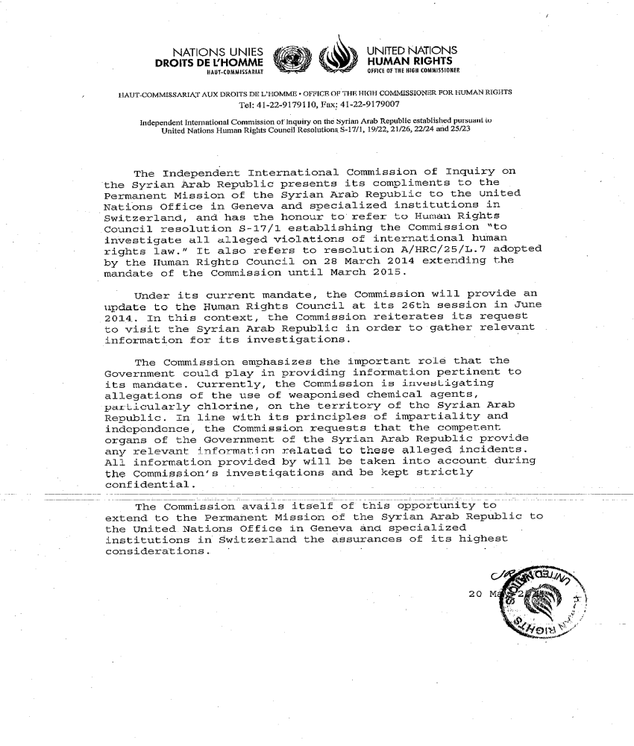
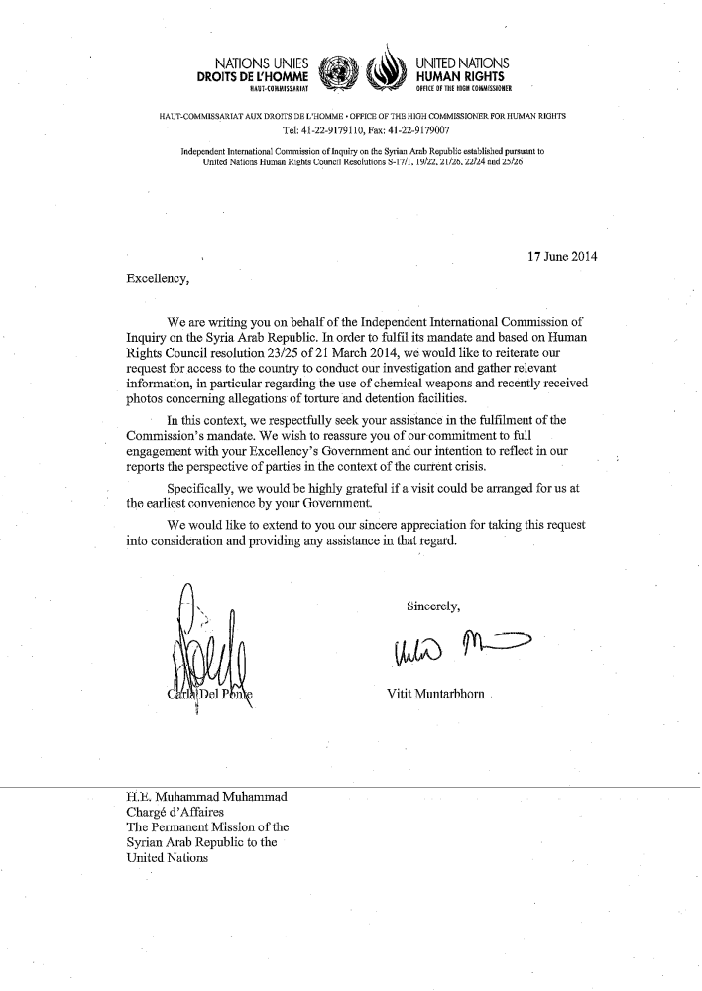

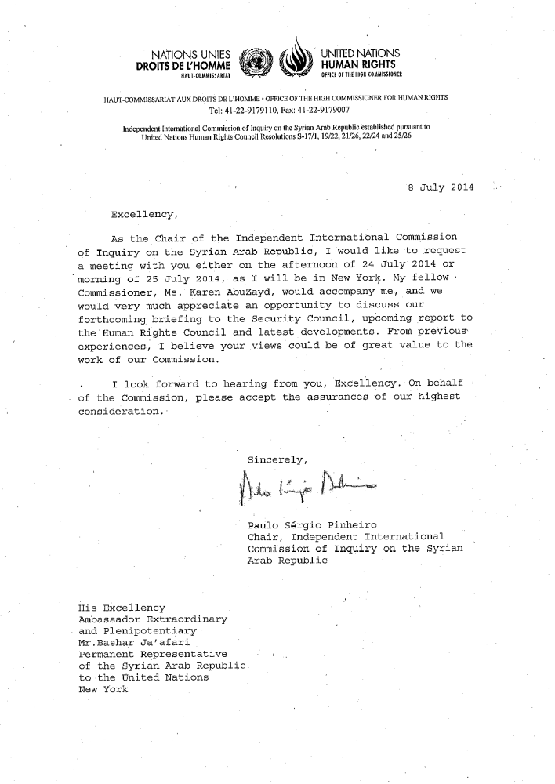
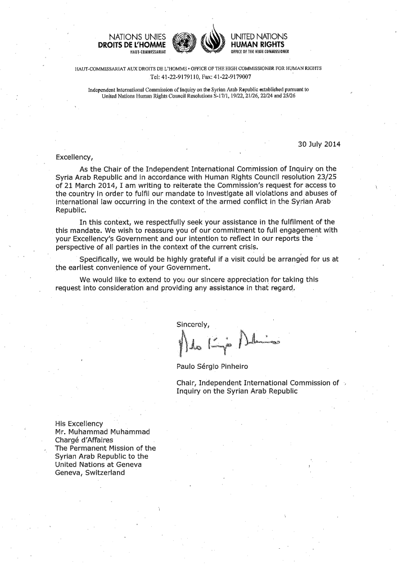
Annex II
[English only]
Political context
1. Despite the efforts of the previous Joint Special Representative (JSR) Lakhdar Brahimi, a political stalemate continued to impede progress towards a negotiated solution. The Geneva 2 talks, which took place between 22 and 31 January 2014, failed to bridge the diametrically opposed positions of the Government and the National Coalition for Revolutionary and Opposition Forces (the Coalition). The Government continued to prioritise the fight against terrorism while the Coalition demanded immediate engagement on modalities for the transitional period. Brahimi’s official resignation on 13 May has further complicated the prospect of bringing the parties back to the negotiating table. On 10 July, Secretary-General Ban Ki-Moon appointed Special Envoy Staffan de Mistura in a bid to revive the political process.
2. The likelihood of a political solution was further weakened by the results of the Syrian presidential elections held on 3 June, with President Assad reportedly winning 88% of the vote, and the gradual yet consistent military gains made by Government forces in certain areas. The Government has become politically and militarily entrenched and is, consequently, less likely to engage in a political process. The Coalition had categorically rejected the elections while President Assad portrayed them as a measure of legitimacy. The presidential inauguration on 16 July drew further regional and international criticism, including from the EU and the US. Russia and Iran stressed that the election results have reinforced President Assad’s authority and reflected his popular base of support.
3. The Coalition continued to suffer from internal divisions. Against the backdrop of competing interests of regional and international actors which provide military and financial support, divisions were particularly evident in the lead-up to the election of its current president, Hadi al-Bahra, on 9 July. While still representing the largest political umbrella for the Syrian opposition abroad, the Coalition continues to struggle to establish reliable links with local military councils and other, predominantly Islamist, forces inside the Syrian Arab Republic. Recent conflicts within the Coalition’s Supreme Military Council – intended to represent various ‘moderate’ military factions – are symptomatic of this disconnect.
4. Influential states continue to provide financial and military support to the various warring parties in the Syrian Arab Republic, reinforcing the existing political and military impasse. Significant changes in the conflict dynamics, however, have altered the regional and international approach towards the Syrian conflict. The emergence of ISIS as a potent military force, both in the Syrian Arab Republic and Iraq, has increased States’ caution, particularly in terms of supplying military aid to armed groups. Fears have arisen that any supplied weapons may be used by ISIS. The continued military and political fragmentation of the opposition has markedly reduced its overall effectiveness and compromised the trust of its regional and international backers.
5. With ISIS representing a regional and international threat, many States have shifted their priorities towards limiting its influence and preventing any potential spillover. Fighting extremism has become a common cause for States with otherwise conflicting interests, potentially signalling further changes in Governments’ policies towards the conflict.
6. The Security Council issued resolution 2165 (2014) on humanitarian cross-border aid on 15 July. Despite consensus on the grave violations being committed inside the Syrian Arab Republic, the Security Council to was unable to ensure implementation of its own call for accountability in resolution 2139 (2014), failing to refer the situation to the International Criminal Court. This impasse must be replaced by a genuine political will to bring the parties back to the negotiating table with the participation of all Syrian political actors.

Annex III
[English only]
Humanitarian context
1. With 6.5 million internally displaced persons and 2.9 million registered refugees, Syria has become the world’s worst humanitarian catastrophe. According to UN agencies, 10.8 million Syrians are in need of urgent humanitarian assistance inside the country, 241,000 people still live under siege and 4.7 million reside in hard-to-reach areas. Despite the passing of resolution 2139 (2014), insecurity, hostilities and administrative restrictions continue to prevent humanitarian access to a growing number of locations. The level of obstruction to the delivery of aid by all warring parties was qualified as “inhuman” by OCHA’s Under-Secretary-General Valerie Amos.
2. Areas considered safe havens by families forced into repeated displacements came under attack. In June, the shelling of a camp of internally displaced persons in Ash-Shajarah, Dara’a, resulted in dozens of casualties.
3. The ever-growing influx of refugees into Lebanon, Turkey, Jordan and Iraq has heightened tensions between Syrians and their host communities, threatening the security of the entire region. Cases of forcible returns and denial of access are on the rise. Palestinian refugees seeking safety in neighbouring countries are particularly affected by these factors.
4. Syrian women and children form the vast majority of refugee and internally displaced communities. The social and economic impact of the conflict has placed them at increased risk of abuse and exploitation. Child marriages and sexual violence emerged as prominent issues in refugee camps, with devastating consequences on the education and health of Syrian girls.
5. Despite immeasurable operational challenges and deliberate attacks against them, humanitarian agencies and NGOs continued to provide life-saving assistance to Syrians in need, including through polio vaccination campaigns, water sanitation programmes and medical items distributions throughout the country.
6. The unanimous adoption of resolution 2165 (2014) authorising the delivery of humanitarian assistance across borders via Turkey, Jordan and Iraq is a very important step forward. The first convoy from Turkey through the Bab Al-Salam crossing took place on 24 July, without any reported incident. The resolution potentially opens up direct routes to approximately three million people caught in the conflict.
Annex IV
[English only]
Specific mandate on massacres
1. Acting upon the request of the Human Rights Council to investigate all massacres, the commission adopted the following working definition of massacre:
An intentional mass killing of civilians not directly participating in hostilities, or hors de combat fighters, by organized armed forces or groups in a single incident, in violation of international human rights or humanitarian law.
2. Massacres include multiple instances of the war crime of murder, the war crime of sentencing or execution without due process and the war crime of attacking civilians, perpetrated in the context of and associated with the ongoing non-international armed conflict in the Syrian Arab Republic. When murder is committed as part of a widespread or systematic attack directed against a civilian population, perpetrated pursuant to or in furtherance of a State or organizational policy, the commission of massacres may amount to the crime against humanity of murder.
3. While the majority of civilian casualties resulted from indiscriminate or disproportionate attacks, primarily aerial bombardments, these killings do not fall within the definition of a massacre. Where there are reasonable grounds to believe that the shelling, bombardments or bombings intentionally targeted civilians, such attacks fall within the definition and are detailed below.
4. Given the lack of access, special mandate to investigate massacres and delay in reporting, massacres perpetrated outside of the reporting period are also documented.

1. Government forces
Damascus governorate
Beit Saham, Rif Damascus, 14 and 18 December 2013
5. In December 2013, a negotiation aimed at opening roads for food and medicine and to allow civilians to leave took place between Government forces and the local committee of Beit Saham. On the understanding that the negotiation had been successful, civilians attempted to leave on 14 December. Government forces opened fire on the civilians, killing approximately 15 and forcing survivors back into the besieged area. On 18 December, several hundred civilians from Beit Saham and other towns in eastern Ghouta, in desperate need of food and understanding that an agreement had been reached, again attempted to leave. While there are reasonable grounds to believe that some armed fighters were accompanying them, the convoy was overwhelmingly civilian. Government forces again opened fire, killing at least 30 civilians and wounding many others.
Hay Al-Qaa, Rif Damascus, early March 2014
6. During the Government offensive in Yabroud, a house was hit by a barrel bomb killing an entire family of four, including two children. A man who helped retrieve their bodies from the rubble stated that all the victims were civilians and that there was no presence of armed fighters in the area. A resident stated that “if they wanted to hit a house, they would destroy the whole neighbourhood,” suggesting a punitive element to the attacks.
Hawsh Arab, Rif Damascus, late March 2014
7. In late March, a helicopter dropped a barrel bomb on a house in Hawsh Arab, causing its total destruction and killing two women and four children. According to surviving relatives, there were no armed group fighters present in the house or its vicinity as armed groups were positioned in the hills and mountains around the village. Former residents of Hawsh Arab stated that the aerial bombardment of civilians was intended to cause their displacement as part of a scorched earth policy to prepare the area for a ground assault.
Aleppo governorate
Al-Sukkari district, Aleppo city, 18 January 2014
8. At approximately 3pm, a Government helicopter dropped three consecutive barrel bombs on a street intersection in Al-Sukkari district. An alley of 20 residential buildings was affected by the attack, sustaining extensive damage. A victim of the attack, a 15-year-old boy, described how he was with his brother, three of his cousins and a friend in front of his house when they heard a hovering helicopter. His 15-year-old cousin was killed in the attack, in addition to a reported 30 civilians including women and children.
Qadi Askar, Aleppo city, 30 January 2014
9. A barrel bomb was dropped on a residential neighbourhood in Qadi Askar, landing 50 metres away from the Sa’ad Alla al Jabry School, killing 16 civilians including women and children, and maiming dozens more. The attack caused extensive destruction of residential and commercial buildings. Armed groups stationed in Qadi Askar were located over 300 metres from the site of the attack.
Tariq Al-Bab, Aleppo city, 2 February 2014
10. At 9am, a Government helicopter dropped two barrel bombs near a mosque in Tariq Al-Bab next to Al-Halwaneya roundabout. Another barrel bomb was dropped shortly thereafter, killing 10 people including women and children. A victim of such attacks stated, “the attacks happen at prayer time on Friday because they know that is where people go at that time.” A doctor who treated victims of the attack at a field hospital in Aleppo stated that he saw no armed group fighters among the killed or injured. According to residents of Tariq Al-Bab, there are no armed group bases or checkpoints located near the Al-Halwaneya roundabout.
Al-Sukkari district, Aleppo city, 4 February 2014
11. On 4 February, two barrel bombs were dropped on civilian objects in Al-Sukkari district. The first barrel bomb hit a five-storey residential building, causing its collapse. At the same time, a barrel bomb hit a vegetable market. The attacks killed at least 5 people, all civilians and wounded countless others. This attack was part of an intensive period of bombardment on Aleppo from 1 to 5 February, which resulted in hundreds of civilians killed, including dozens of children. A mass exodus of civilians from Al-Sukkari and other eastern districts of Aleppo followed.
Masakin Hanano, Aleppo city, 4 February 2014
12. On 4 February, a Government helicopter dropped a barrel bomb on Masakin Hanano, hitting two residential buildings and a mosque. The attack killed 12 people, most of whom were children attending religious classes at the mosque. The attack followed a pattern of barrel bombs hitting soft targets in Masakin Hanano in early February, including two primary schools, a mosque and a field hospital. Each attack resulted in the deaths of dozens of children, many of whom were internally displaced persons from Rif Aleppo.
Al-Haydaria, Rif Aleppo, 9 February 2014
13. As civilians were fleeing Aleppo following an intensive period of bombardment from 1 to 5 February, at 8am on 9 February a Government helicopter dropped a barrel bomb on Al-Haydaria roundabout, a transport hub and gathering point for vehicles transporting internally displaced persons. A victim of the attack, a mother whose three children were severely injured, stated that there were over 200 people gathered around the area, all civilians waiting for buses. She described seeing “dead bodies, some charred and others with severed limbs, scattered all over the place, people screaming in pain and others burning inside minibuses.” Another barrel bomb was fired at minibuses heading from Al-Haydaria toward the border. The attacks hit approximately 10 vehicles, killing at least 20 civilians, including women and children, and injuring many more.
Al-Sakhour, Aleppo city, 11 February 2014
14. On 11 February, a Government helicopter dropped three barrel bombs on residential buildings and a vegetable market in Al-Sakhour. At least 7 civilians were killed and over 14 others severely injured by the attacks, which caused extensive damage to civilian infrastructure. As a result of this and other barrel bomb attacks on Al-Sakhour, one resident described the district as “flattened.” Victims of the attack fled Aleppo city, as part of a mass displacement toward the border.
Masakin Hanano, Aleppo city, 17 February 2014
15. On 17 February, a Government helicopter dropped a barrel bomb on a densely populated roundabout. The area was a well-known and crowded bus station and transport hub. A witness of the attack described seeing victim’s bodies and limbs strewn about a large area, with many bodies torn to pieces. This made it “impossible to make a body count”. Available information indicates that over 15 people, all civilians, were killed in the attack. There were no military targets in the immediate vicinity of the targeted area.
Ain Al-Tal (Handarat) Palestinian Camp, Rif Aleppo, 21 and 22 February 2014
16. Palestinian refugees living in Ain Al-Tal camp described how a Government helicopter dropped two barrel bombs on the camp, killing a woman and a child and injuring at least 8 others on 21 February. Following the attack, approximately 100 people fled the camp toward the border. While travelling on the road from Al-Jandoul Handarat to Azaz on 22 February, a Government helicopter dropped bombs on their cars, indicating a deliberate attempt to target those fleeing the camp.
Fafeen, Rif Aleppo, 22 February 2014
17. After a barrel bomb was dropped near Fafeen on 22 February, a family living nearby rushed to collect their belongings and flee the area. Surviving family members described how they were about to leave their house, when a Government helicopter dropped a barrel bomb in their yard, killing their relatives: three young women, a female child and a female adult.
Al-Sukkari, Aleppo city, 23 March 2014
18. On 23 March at 10am, a Government fighter jet fired a missile at Al-Wadi street, a crowded thoroughfare in Al-Sukkari. A victim who was in his workshop on the street described how his 13-year-old nephew was killed immediately as a result of severe shrapnel injuries. At least 20 people were killed in the attack, including 5 children. As a result of the attack, residential buildings in the area sustained heavy damage. Victims stated that there were no military targets or armed group presence on Al-Wadi street.
Al-Shaar, Aleppo city, 4 and 6 April 2014
19. A Government helicopter dropped barrel bombs on a residential neighbourhood in Al-Shaar district, just prior to Friday prayers. The attack killed 20 people, among them women and children. Dozens more were injured in the attack, which caused significant destruction of residential infrastructure in Al-Shaar. On 6 April, a helicopter targeted the same area with two consecutive barrel bombs, killing at least 20 civilians. The attacks appeared to target shops, residential buildings and crowded streets.
Tel Jabin, Aleppo, 5 April 2014
20. On 5 April, a Government helicopter dropped two barrel bombs on Tel Jabin, killing 10 people, including a woman and her three children. Tel Jabin is a hub for IDPs.
Tel Jabin, Aleppo, 20 April 2014
21. On 20 April, a Government helicopter hit Tel Jabin with two consecutive barrel bombs which killed 8 people, including a woman and 4 children. At least 20 other people were severely injured in the attack.
Biideen, Aleppo city, 20 April 2014
22. A Government helicopter dropped four barrel bombs in close sequence on Biideen neighbourhood. The attack was accompanied by artillery and mortar shelling, leading to the deaths of 30 people and injury of dozens more. The victims of the attack were civilians buried under the rubble of collapsed buildings hit by barrel bombs. The area appeared to be targeted due to the large number of internally displaced persons seeking shelter from hostilities in nearby areas.
Al-Fardous, Aleppo city, 20 April 2014
23. On 20 April, a Government helicopter consecutively dropped two barrel bombs on Al-Fardous neighbourhood, a densely populated area. The first barrel bomb hit a crowded commercial street. The second bomb fell 400 metres away, on residential buildings. At least 40 people were killed, among them women and children. The bombs were dropped around 5pm, when the street was most crowded with people shopping for basic goods. The frontline in Aleppo city is three kilometres away from the site of the attack. Victims of the attack stated that there was no armed group presence in the vicinity.
Ain Jalout School, Al-Ansari al-Sharqi, Aleppo city, 30 April
24. On the morning of 30 April, Ain Jalout School in Al-Ansari al-Sharqi, Aleppo city, was hit by two consecutive missiles. The attacks killed 35 people, including 33 children, and severely injured approximately 40 more. The school was targeted at a time when parents and children gathered in large numbers for an exhibition of children’s artwork depicting their experiences of war. Ansar Al-Aqida uses a building that is part of the same school complex as a barracks for approximately 50 fighters. However, the timing of the attacks and their repetitive nature indicates that the attacks had the intention of wounding and killing as many people as possible. Ain Jalout School had previously been attacked in 2013. The character and context of the attacks on the school make it apparent that Government forces could not consistently mistaken their target to be the school building rather than the adjacent barracks of Ansar Al-Aqida. In addition to wounding and killing children, attacks on schools damage educational infrastructure and militarise civilian areas.
Al-Halak, Aleppo city, 1 May 2014
25. At 4pm on 1 May, a Government fighter jet fired three consecutive missiles on Al-Halak market, killing at least 40 and wounding over 100 people. A victim of the attack described that at the time of the attack the market was crowded with people, all of whom were civilians buying basic goods such as fuel for generators.
Armanaz, Aleppo, 5 May 2014
26. On 5 May around 12pm, Armanaz was hit with two rockets fired from a fighter jet. The two rockets consecutively hit the same residential building, which was inhabited by civilians. Residents of the building and victims of the attacks stated that there were neither military activities nor armed group fighters in the area. A man who witnessed the attack and helped pull bodies from under the rubble described seeing the dead bodies of three children and a woman. Nearby buildings were severely damaged. Residents whose homes were destroyed were forced to leave Armanaz.
Al-Sukkari, Aleppo city, 10 May 2014
27. A construction site in Al-Sukkari was attacked on the morning of 10 May with a barrel bomb, killing 16 men. The area, under the control of Liwa al-Tawhid at the time of the attack contained no military targets in the immediate vicinity of the attack. According to victims, there was an armed group checkpoint 300 metres away from the site. The attack appeared to target clear evidence of civilian life.
Bustan Al-Qasr, Aleppo city, 30 May 2014
28. At 1pm on 30 May, a Government helicopter dropped two barrel bombs on Karraj Al-Hajz street. A man described how he rushed to the site of the attack and witnessed many women and children among the dead and wounded. While first responders were collecting the dead and wounded, the site was targeted a second time. At least 10 people were killed in the attack and 22 others injured. According to doctors who treated the victims at Al-Zarzour hospital, most of the casualties were civilians.
Al-Sakhour, Aleppo city, 10 June 2014
29. On 10 June, two consecutive barrel bombs targeted a site in Al-Sakhour located 250 metres from an armed group base. The bombs hit residential buildings, adjacent to a mosque and Al-Sakhour hospital. The bombs caused serious damage to houses and resulted in the deaths of 10 children, among other civilians. Residents who helped collect their bodies described how without proper tools and machinery, many of the victims were trapped under the rubble of their homes until days following the attack.
Al-Sukkari, Aleppo city, 16 June 2014
30. On 16 June, a Government helicopter dropped two barrel bombs on Al-Sukkari district. The first bomb hit a residential building. The second bomb, fired less than 10 minutes after the first, hit a main intersection close to the Al-Sukkari Local Council located less than 50 metres away from the site of the first attack. The intersection was deliberately targeted. Victims described that the local council office was conducting two days of aid distribution, with hundreds of families gathering to collect assistance at the time of the attack. It is unlikely that Government forces could have mistaken the crowded intersection with nearby Ahrar Al-Sham bases in Al-Sukkari, stationed in the Al-Thawra Elementary School and Al-Rabi’ee wedding hall. The timing and deliberate nature of the attack indicates that civilians were its object.
Dara’a
Jasem, Dara’a, 12 February 2014
31. On 12 February, people shopping at a market in Jasem heard the sound of a helicopter flying overhead and started running to hide. Moments later, a barrel bomb dropped on the market, killing 16 persons. Shops and buildings in the marketplace were destroyed. The marketplace and the people shopping appeared to be the object of the attack.
Dara’a city, 16 May 2014
32. At 2pm, Government forces aerially bombarded a residential neighbourhood in Dara’a city, killing 6 civilians, including a woman and a 5-year-old child and injuring many others. First responders and nearby residents that rushed to their assistance were targeted 15 minutes after the initial attack, killing many of them.
Dael, Dara’a, mid-June 2014
33. A barrel bomb was dropped on a residential neighbourhood in Dael in mid-June, killing five people including a woman and a child. The closest armed group position was located 1.5 kilometres away. The victims of the attack could not access the nearest hospital as it was in a Government-controlled area and wounded persons were not allowed to pass through checkpoints.
Al-Shajara, Dara’a, 18 June 2014
34. On 18 June, a camp for internally displaced persons located in and around a school in Al-Shajara was hit by a barrel bomb. Twelve people were killed in the attack and two others died of severe injuries before reaching medical treatment. According to doctors who treated victims of the attack, all those injured were civilians. They bore multiple injuries, many resulting in amputations due to severe wounds to their limbs, consistent with the damage caused by barrel bombs.

2. Non-State armed groups
Anti-Government armed groups
Rif Damascus
Adra, Rif Damascus, 11 and 12 December 2013
35. On 11 December 2013, armed groups – including Jabhat al-Nusra and Jaysh al-Islam – entered Adra. They entered civilian houses and, in some instances, screened and removed men on sectarian grounds. At least 15 men were shot and killed after being removed from their houses.
Badr al-Din al-Husseini Institute, Damascus Old City, 29 April 2014
36. Badr al-Din al-Husseini Institute in Shaghur, Old City of Damascus on 29 April was shelled by anti-Government armed groups stationed in Jobar, resulting in the deaths of 17 and injury of over 86 children and adults. It followed a clear pattern of armed groups using their artillery and mortar shelling capabilities to target soft targets, in particular school yards in the Old City of Damascus, where numerous children congregate. Anti-Government armed groups have intentionally targeted civilian localities due to their perceived support of the Government, occasionally along sectarian lines. The shelling of schools in Damascus is calculated and deliberate.
Hama
Ma’an, Hama, 24 December 2013
37. On 24 December 2013, an anti-Government armed group entered Ma’an, a village 30 kilometres north of Hama city. While some local men attempted to defend the village, they were quickly overrun. Armed group fighters killed between 10 and 15 civilians, including women and children, inside the village. All of those killed were Alawite. Later, Liwa al-Islam, Jabhat al-Nusra and Jund Al-Aqsa posted videos of the attack. The majority of Ma’an’s residents fled following this attack. Most of those who remained were too poor, elderly or disabled to leave.
Ma’an, Hama, 9 February 2014
38. In the early hours of 9 February, residents woke to the sound of gunfire and mortar shelling. Armed groups, including Jabhat al-Nusra and Liwa al-Qasa attacked Ma’an. Again, some men in the village attempted to defend it but they were quickly overrun. Approximately nine of them were shot and killed while fleeing. At least 20 civilians were shot and killed in the attack.
Al-Salamiya, Hama, 11 April 2014
39. On 11 April, a group affiliated to Jabhat al-Nusra attacked Al-Majbal checkpoint, 20 kilometres from Al-Salamiya. The checkpoint, run by approximately 22 Syrian army and members of the National Defence Force, was intended to cut the rebel supply lines to Ar Raqqah governorate. The checkpoint had been the object of attack previously but on this occasion, was overrun. Some were killed in the initial attack while others managed to escape. Approximately 13 were captured alive and immediately executed. Three bodies were burnt beyond recognition and ten had been reportedly, though it is unclear whether they were beheaded while still alive.
Aleppo
Al-Kindi hospital, Aleppo city, Aleppo, 4 January 2014
40. Al-Kindi hospital, in northern Aleppo city, occupied a strategic area close to a front line and overlooking several opposition-controlled neighbourhood. It had not been used as a hospital since 2012 when it was captured by the FSA. In December 2012, it was turned into a military base by the Syrian army. Aside from being briefly held by the FSA in May 2013, it remained under the control of the Government under 20 December 2013. On that date, Jabhat al-Nusra took control of the hospital, after targeting it with two suicide bombings. While most of the Syrian army soldiers escaped, between 10 and 15 were captured by Jabhat al-Nusra. The group later released a video showing its fighters shooting the captured soldiers in the head.
Homs
Arman Street, Homs city, 6 March 2014
41. Arman street is a main commercial thoroughfare in Homs city. Residents in that area are mainly Christian and Alawite. There are no military targets in the area, considered to be one of the safer places in the city. At approximately 3pm on 6 March, a car bomb exploded on the entrance of the street, killing at least nine people, including women and children. It also injured several dozen people.
Al-Zahra, Homs city, 17 March 2014
42. On 17 March, an armed group detonated a car bomb in the Al-Zahra neighbourhood of Homs city. Al-Zahra is a residential area with a mixed population of Sunni, Shia and Alawite. There are no checkpoints or other military targets in the area. The bomb exploded on a crowded, narrow, commercial street. As the explosion occurred at approximately 4.30pm, the area was crowded with civilians. At least six people died instantly with two more dying later in hospital. More than a dozen were injured.
Karm Al-Louz, Homs city, 9 April 2014
43. Within a period of 20 minutes on 9 April 2014, two car bombs exploded in the Karm Al-Louz neighbourhood of Homs city. The neighbourhood is a middle-class residential area, populated mainly by Alawites. There were no soldiers based in the area nor were there any other military objectives.
44. The first car was parked near to a centre which distributed gas cylinders, which exploded along with the car on detonation. As paramedics, firefighters and civilians rushed to the scene of the bombing to assist the injured and douse the flames, a second car bomb exploded. The second car was parked on the road between the Al-Eiyadat Al-Shamila Hospital and the site of the first attack and appears to have deliberately targeted first responders carrying the injured to hospital. Jabhat al-Nusra has claimed responsibility for the double bombings.
Oshak street, Homs city, 14 April 2014
45. In the early afternoon of 14 April, a car bomb exploded in Oshak street in Homs city. The car had been parked in front of shops in a commercial area. There were no military checkpoints or installations in the area surrounding the explosion. The dead and injured were taken to the Al-Za’eem hospital. Six civilians were killed instantly. Scores more were injured.
Akrama, Homs city, 18 April 2014
46. On Friday 18 April 2014 a car bomb exploded near Bilal Al-Habashi Mosque, at the edge of Akrama neighbourhood. Friday prayers had just finished and the area was crowded as worshippers exited the mosque. The explosions did not target any military objectives. Fourteen civilians were killed instantly, including a 13-year-old boy.
Al-Abassiya, Homs city, 29 April 2014
47. Al-Abassiya neighbourhood in Homs city is a crowded lower-class neighbourhood, populated primarily by members of the Alawite community. The ground floors of buildings are filled with clothes and food shops, which residents live in apartments above. There was no military presence in the area affected by the bombing.
48. On 29 April, the neighbourhood was hit with a double car bombing. The first car bomb exploded at approximately 1pm. After the first explosion, concerned residents ran to the scene to assist the injured. Ten minutes later, another car, parked 30-40 metres away, exploded. The second explosion was far more powerful than the first and deliberately targeted people who had rushed to the area to assist victims of the first bombing. The second bombing also caused a large fire. The impact site was a scene of horror with bodies of those killed on fire or torn apart by shrapnel.
49. At least 45 people were killed instantly in the two bombings, many of them below the age of 18. Some victims were killed by shrapnel while others had burned to death. Scores more were injured. Many of the injured suffered severe burns and died later in hospital. Jabhat al-Nusra claimed responsibility for these attacks.
Al-Hiraqe village, eastern Homs countryside, 2 June 2014
50. Al-Hiraqe village is part of the district of Al-Mukharam city in the eastern Homs countryside. It is home to approximately 4,000 residents, mainly Alawites. A car bomb was detonated in the village at 1pm on 2 June, the day before Syria’s Presidential elections. The explosion killed at least 15 civilians, including women and children. Three of the children killed were under 6. One of the female casualties was 70 years old. There were no military targets in the area. Many of the bodies were dismembered by shrapnel. Jabhat al-Nusra has claimed responsibility for this attack.
Wadi el-Dahab Square, Homs city, 13 June 2014
51. Wadi el-Dahab is a residential middle-class neighbourhood in Homs city. There are no military targets present in it. On 13 June, an armed group exploded a car bomb in the main square, killing seven civilians.
Wadi el-Dahab Square, Homs city, 19 June 2014
52. On 19 June, an armed group exploded a car bomb on the main square of Wadi el-Dahab. Nineteen civilians were killed.
Islamic State of Iraq and Al-Sham
Aleppo
Qadi Askar neighbourhood, Aleppo city, early January 2014
53. By late 2013, ISIS had taken over a former Ophthalmology Hospital in Qadi Askar neighbourhood of Aleppo city. It used the building as its headquarters and set up a makeshift detention centre in its basement. Previously the building had been held by the Islamic Front and contained its Sharia court. With ISIS refusing to accept the court’s authority, relations between the groups deteriorated. ISIS was abducting people who had been critical of it or who had worked with foreigners, such as journalists. In early January, fighting erupted between ISIS and Liwa al-Tawhid, eventually forcing ISIS to negotiate a withdrawal eastwards, out of the city. On Liwa al-Tawhid’s entering the premises, several dozen bodies were found. There were all men, bound and blindfolded, who had recently been shot at close range.
Ar Raqqah
Ar- Raqqah city, Ar Raqqah, 29 April 2014
54. On 29 April, as detailed in paragraph 32 of the present report, ISIS publicly executed seven males, five of them under the age of 17 years in Ar Raqqah city.
Al-Hasakah
Al-Talaliyah, Al-Hasakah, 29 May 2014
55. Al-Talaliyah is a Yazidi village in western Al-Hasakah governorate. When ISIS began to assert itself in the area, the village’s population fled. The village was occupied by Sunni Arabs, most of who had been displaced from Safira by Government bombardments. In late May, ISIS and the YPG, the Kurdish armed group, were engaged in violent clashes around Al-Talaliyah.
56. On 29 May, ISIS fighters entered the village. There they began to execute villagers, including women and young children, believing them to be Yazidis. According to survivors, the villagers, desperate to show that they were Muslims, began to recite the verses of the Quran. Bar one fighter from Iraq, none of the ISIS fighters spoke Arabic. The Iraqi fighter intervened, preventing further killings. Approximately 15 people were killed before the Iraqi fighter could translate to the other ISIS fighters that the residents were Sunni Arabs.
3. Unknown Perpetrators
57. In the incidents detailed below, while there are reasonable grounds to believe the killing occurred as described, it has not yet been possible to determine the identity of the perpetrators to the commission’s standard of proof.
Aleppo
Khanat Assan, Aleppo, December 2013
58. In December 2013, a mass grave containing the bodies of at least four adult men and one boy was found on the ground of the El-Beifat poultry farm outside of Khanat Assan. The bodies were said to belong to El-Abdullah family, who had been abducted from Khanat Assan on 2 December. A video, released later by an armed group, showed foreign fighters in army uniforms, speaking Chechnyan. They displayed no flags or insignia and did not state whether they belonged to ISIS or another armed group.
Hreitan, Aleppo, a date prior to 14 February 2014
59. Several mass graves were found on the grounds of the Secondary Institute of Electricity, which also served as ISIS’s headquarters until it was forced out by anti-Government armed groups on 14 February. The dead were adult men. It is not clear how they were killed. Further, it has not been possible to determine the length of time that the bodies had been buried or the approximate date of death.
60. Another mass grave, containing the bodies of nine fighters from anti-Government armed groups, was found at Al-Malah farms, near Hreitan. The bodies were dumped in a well on the property.
4. Findings
Government forces
61. Government forces stationed around eastern Ghouta, namely elite units including the 4th Division, Republican Guard and 3rd Division, committed the war crime of attacking civilians on 14 and 18 of December 2013. The victims of the attacks were easy targets to the perpetrators who were positioned in checkpoints blocking all routes out of eastern Ghouta. The sequence of events around the efforts to negotiate the opening of roads demonstrates that the civilians attempting to leave the besieged area were the object of the attack.
62. The war crime of attacking civilians was committed by Government forces in the context of the offensive on Qalamoun (Rif Damascus) during March 2014. During the documented barrel bomb attacks on civilians in Hay Al-Qaa and Hawsh Arab, there was no military equipment or personnel near the victims’ homes at the time and place of the incident.
63. The war crime of attacking civilians was committed by Government forces throughout the military campaign on Aleppo city and Rif Aleppo. Between 18 January and 16 June, 23 documented instances of aerial bombardment amounted to the war crime of attacking civilians. In addition to reckless disregard to the possibility that the barrel bombs would hit, kill and maim civilians, the collected information shows that the Syrian armed forces attacked civilians, men and women, children and elderly in particular while engaged in typical civilian activities. In all the incidents documented, the information reveals that civilians or civilian objects were directly targeted, resulting in substantial civilian casualties and that the fire was not aimed at any possibly military target. Where military targets were present, they were located at a substantial distance or confined to an easily identifiable position.
64. In most incidents, multiple barrel bombs were dropped consecutively, ensuring maximum damage to their targets. Several attacks demonstrated that the Syrian air forces deliberately targeted civilian rescuers who rushed to help the victims of the first strikes. Such follow-up attacks clearly indicate that civilians were the object of the bombardments. The documented attacks constitute examples of a campaign of attacks against civilians in Aleppo. The gravity of the attacks, established by their scale, pattern and virtually continuous repetition over a six-month period indicates that the war crimes of attacking civilians were committed as part of a plan or policy. The attacks amounted to area bombardment and constituted a large-scale attack on the civilian population of non-State armed group-controlled districts of Aleppo city and Rif Aleppo.
65. The war crime of attacking civilians was committed by Government forces in Dara’a governorate in the course of its aerial bombardment campaign in incidents occurring between 12 February and 18 June 2014. The pervasive and consistent nature of the barrel bomb attacks and their perpetration resulted in the terrorization of the inhabitants of Dara’a. The documented incidents are examples of the aerial campaign on non-State armed group-controlled areas of Dara’a governorate, which have killed and wounded countless civilians during daily activities or while in their homes. Follow-up attacks targeting civilian rescuers and first responders and attacks targeting internally displaced persons demonstrate the deliberate nature of the bombardment.
Non-State armed groups
66. The war crime of murder was committed in massacres perpetrated by anti-Government armed groups, namely by Jabhat al-Nusra and Jaysh al-Islam in Adra (Rif Damascus) in December 2013, by Jaysh al-Islam, Jabhat al-Nusra and Jund al-Aqsa in Ma’an (Hama) in December 2013, Jabhat al-Nusra in Aleppo in January 2014, Jabhat al-Nusra and Liwa al-Qasa in Ma’an (Hama) in February 2014, and by a group affiliated by Jabhat al-Nusra in Al-Salamiya (Hama) in April 2014. In all documented incidents, anti-Government armed groups killed civilians or persons hors de combat in close quarters.
67. The war crime of attacking civilians was perpetrated by armed groups stationed in Jobar (Rif Damascus) on 29 April 2014 in their attack on Badr al-Din al-Husseini Institute in the Old City of Damascus. The institute is located in a civilian neighbourhood with no military targets in its vicinity. Civilians, in particular children attending the institute, were the object of the attack. The attack followed a pattern of shelling of schoolyards in Damascus demonstrating the deliberate and calculated nature of the attack.
68. The war crime of attacking civilians was committed by Jabhat al-Nusra and other unidentified armed groups in their car bomb attacks on Government-controlled neighbourhoods of Homs city between 6 March and 19 June 2014. The attacks did not target any military objectives, nor was there any military equipment or personnel near the sites of the attacks. The double car bombings in Karm Al-Louz on 9 April and in Al-Abassiya on 29 April were clearly intended to cause mass civilian casualties with the second car bombs targeting the civilian rescuers and first responders helping the victims of the first attacks. The nine documented attacks formed part of single campaign of spreading terror among the civilian population of Homs city by Jabhat al-Nusra.
69. The war crime of murder and the war crime of execution without due process were committed by ISIS in Aleppo in early January, in Ar Raqqah city (Ar Raqqah) in April and in Al-Talaliyah (Al-Hasakah) in May 2014. The execution of the victims, usually accused of affiliation with other armed groups, was linked to the ongoing non-international armed conflict in Syria. In its public display of bodies and failure to honourably inter the bodies in accordance with the rites of the religion of the deceased, ISIS has violated customary international humanitarian law. ISIS carried out public executions to instil terror among the population, ensuring submission to its authority.
70. ISIS has committed acts of violence against the civilian population under its control in Al-Raqqah and eastern Aleppo governorates. This is a continuation – and a geographic expansion – of the widespread and systematic attack on the civilian population identified in A/HRC/25/65. ISIS, a structured group, directs and organises these acts of violence against civilians, evincing an organisational policy. While the victims appear to be largely hors de combat fighters, the unlawful killings in Al-Raqqah and identified localities in Aleppo governorates, detailed above, form part of this attack. In perpetrating these killings, ISIS has committed the crime against humanity of murder.
Unknown perpetrator
71. Where neither the perpetrator nor the circumstances of the deaths could be determined, incidents remain under investigation.
Annex V
[English only]
Specifically protected persons and objects
1. Government forces
1. The healthcare system has been severely affected in the course of military operations carried out by Government forces, as well as through a deliberate and systematic campaign to persecute medical staff treating anyone perceived to be opposing the Government. The prevention of access to healthcare continues to be used to punish and subdue civilians residing in armed group-held or contested areas, or persons perceived to be affiliated with armed opposition groups.
2. Healthcare infrastructure and medical facilities in contested areas have been damaged in hostilities and destroyed by targeted attacks. The flight of healthcare professionals owing to fear of arrest, and the death and injury of medical staff has left armed group-controlled areas without adequate medical care. The continued denial and removal of medical supplies from humanitarian aid deliveries and the collapse of the country’s pharmaceutical industry have further worsened the provision of medical care.
3. Medical functions continue to be targeted as part of a broader assault on civilians. During the Government’s offensive on Yabroud (Rif Damascus) in early February, a hospital in which internally displaced persons were seeking shelter was shelled, killing three and injuring seven people. As the military operation escalated, medical clinics were targeted and destroyed on 15 and 16 March. On 15 May, Government forces dropped two consecutive vacuum bombs on Radwan field hospital in Jasem (Dara’a), destroying the facility. Four medical personnel and two children were killed, and more than 15 were critically injured. This facility was the sole source of medical care in Jasem. Residents described how the hospital’s destruction and resulting lack of medical care led to an increase in infant mortality.
4. During the military campaign on Aleppo, Government forces attacked medical facilities to achieve military advantage. In eight documented attacks between early February and 24 June, Government forces dropped barrel bombs on M10 Trauma Field Hospital in Masakin Hanano, Aleppo city. Doctors and patients were killed in the attacks, which damaged crucial infrastructure such as operating rooms and the intensive care unit, as well as life-saving equipment. These attacks have severely limited access to medical care in Masakin Hanano during the barrel bombing campaign on northeastern Aleppo, depriving those injured in Government attacks on Sheikh Najar Industrial Area and around Aleppo Central Prison of medical treatment.
5. On 12 April, Al-Zarzour Hospital, which provides medical treatment for opposition forces based in Al-Ramoussa, Al-Azizia and Al-Layramoun, was targeted by two consecutive barrel bombs. The hospital serves the most heavily bombarded opposition-held districts in Aleppo city, including Al-Ansari al-Sharqi, Al-Sukkari, Bustan Al-Qasr, Salah Al-Din and Al-Mashahed. It was further damaged on 7 May and 18 June, when helicopters dropped a barrel bomb 200-400 metres away.
6. Al-Sakhour Hospital, one of the few remaining medical facilities in eastern Aleppo, was hit by a barrel bomb on 7 February, killing two and injuring 16 people, including four medical staff. In June, Al-Sakhour Hospital suffered seven barrel bomb and missile attacks, causing significant damage to medical equipment and the partial destruction of the facility. Four medical staff were injured in the attacks. Following an attack on 23 June, the hospital was temporarily closed. The attacks severely limited access to medical care in opposition-controlled areas of Aleppo.
7. On the morning of 13 April, a barrel bomb hit the M1 Trauma Hospital in Aleppo, destroying its top floor. The same day, a barrel bomb hit Al-Daqqaq Hospital in Al-Shaar, causing significant damage to its operating rooms, water and sewage infrastructure. On 24 June, Bab Al-Hadid field hospital was attacked by missiles, injuring two patients and damaging equipment. Omar bin Abdulaziz Hospital in central Aleppo city was severely damaged on 5 July by a barrel bomb dropped in its vicinity. In Idlib, Bab Al-Hawa field hospital was hit by two consecutive missiles on 7 June, damaging the facility infrastructure.
8. Across the country, field hospitals and makeshift clinics are concealed in underground cellars and basements. Medical staff at a field hospital in Quneitra noted they do not mark the location with a red cross or red crescent emblem since “once the regime learns where the hospital is, they will attack it.”
9. Government forces and authorities acted in disrespect for medical ethics and the duty of health workers to treat the sick and wounded regardless of affiliation. Doctors, nurses, pharmacists and paramedics arrested and disappeared in 2011 and 2012 continued to be detained or their whereabouts remain unknown. A field hospital doctor detained in Damascus in spring 2013 for aiding the opposition continues to be imprisoned in the Air Force Intelligence Branch at Mezzeh Airport. A nurse working in Douma Hospital, arrested in October 2013 for treating wounded members of the armed opposition, died in the custody of Syrian authorities. In May, his parents were informed of his death and burial in Najha cemetery (Rif Damascus) and instructed to retrieve his identification and belongings from a hospital in Damascus.
10. Attacks on medical personnel and facilities violate common article 3 of the Geneva Conventions and customary international humanitarian law and amount to war crimes. The frequency of attacks on medical facilities in opposition-controlled areas of Aleppo city and governorate is indicative of a deliberate policy. Government forces target healthcare infrastructure with the apparent intention of depriving civilians and fighters injured in Government offensives of medical treatment, increasing the loss of life and the number of persons maimed, wounded or killed. Humanitarian workers continue to be targeted in grave violation of international humanitarian law, hampering the operations of aid organizations.
2. Non-State armed groups
Islamic State of Iraq and Al-Sham
11. In January, a nurse working at a hospital in Byanoon (Aleppo) was abducted by ISIS while transporting a wounded patient. In late January, ISIS detained a pediatrician working for an international NGO in Jarabulus (Aleppo). In early February, three medical staff from a field hospital in Al-Bab (Aleppo) were detained by ISIS and brought in front of a shari’a court before being released. These incidents fit a previously documented pattern of ISIS detaining doctors in contravention of the customary international humanitarian law rule that under no circumstances shall any person be punished for carrying out medical activities.
12. ISIS fighters occupied Al-Jabal Hospital in Al-Bab in January, and have converted the operation rooms to a detention facility. Using hospitals outside their humanitarian function prevents the impartial provision of medical treatment, endangers patients and medical professionals, and compromises the humanitarian function of medical facilities. This has a grave impact on the fulfilment of the obligation under common article 3 to care for the sick and wounded. Failing to respect the emblems of the Geneva Conventions undermines their protective purpose.
13. Journalists continue to be systematically targeted by ISIS. Two foreign journalists were detained by ISIS in Tal Abyad, (Ar Raqqah) after they explained that they were reporting on the ongoing conflict. They were subsequently interrogated and ill-treated in various ISIS detention facilities until late March 2014. On 29 April, ISIS executed a journalist in Tal Abyad. The detention and killing of journalists violates international humanitarian law and may amount to war crimes.
14. Jabhat al-Nusra and Islamic Front fighters stationed near the Old City of Aleppo continue to fire improvised gas-canister explosives at the Citadel, targeting Government snipers stationed within. On 8 May, Ahrar al-Sham fighters remotely detonated explosives packed into a tunnel dug underneath the Citadel, allegedly used as a base for Government soldiers. On 31 May, they detonated a similar tunnel bomb near the Zahrawi market next to the Citadel. Repeated underground high-magnitude shockwaves have caused structural damage to the thirteenth century Citadel, a United Nations Educational, Scientific and Cultural Organization (UNESCO) World Heritage Site.
15. The whereabouts of the Syriac Orthodox and Greek Orthodox Archbishops of Aleppo, Yohanna Ibrahim and Paul Yazigi, abducted in Aleppo in April 2013, and of Father Paolo Dall’Oglio, abducted in Ar Raqqah city in January 2014, remain unknown. Dozens of journalists, both foreign and Syrian, remain in captivity, detained incommunicado because of their professional activities. Religious personnel and civilian journalists enjoy specific protection under international humanitarian law and must be respected and protected by all parties.
Annex VI
[English only]
Map of the Syrian Arab Republic
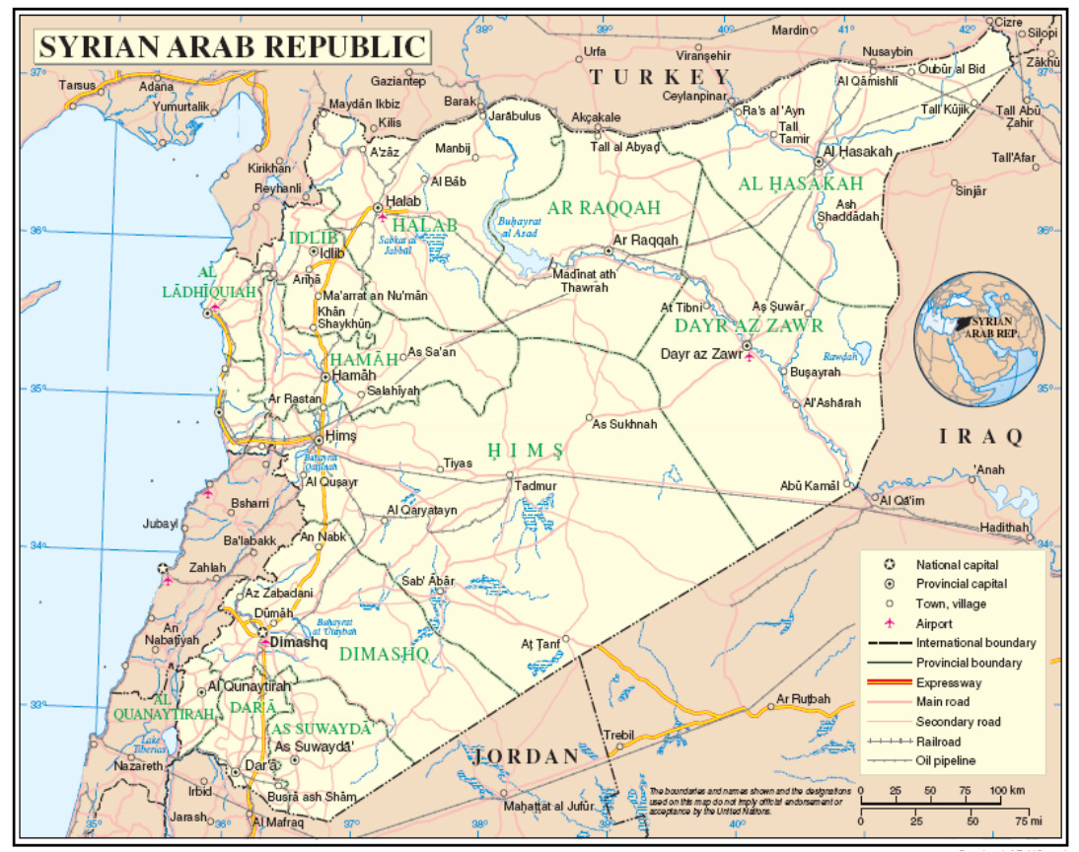

* * The annexes to the present report are circulated as received, in the language of submission only.
? The commissioners are Paulo Sérgio Pinheiro (Chair), Karen Koning AbuZayd, Vitit Muntarbhorn and Carla Del Ponte.
? S-17/2/Add.1, A/HRC/19/69, A/HRC/21/50, A/HRC/22/59, A/HRC/23/58, A/HRC/24/46 and A/HRC/25/65.
? “Government forces”, unless specified otherwise, comprise the Syrian Armed Forces, intelligence forces and associated foreign and local militias, including Hezbollah, the shabbiha and the popular Committees/National Defence Forces.
? See also annex IV.
? See annex IV.
? See annex IV.
? See annex IV.
? See annex IV.
? See annex V.
? HRC resolution 21/26, para. 19.

